# DEEP LEARNING IMPLEMENTATION OF BICEP FITNESS TRAINER

## By

### JUNAID IQBAL KHAN (00000132156)

# 

A project report submitted in partial fulfillment of the requirement for the degree of Bachelors in Electrical Engineering

NUST School of Electrical Engineering and Computer Science,

National University of Sciences and Technology

Islamabad, Pakistan

2020

# Certificate

Certified that the contents and form of project report entitled **“Deep Learning Implementation of Bicep Fitness Trainer”** submitted by Junaid Iqbal Khan have been found satisfactory for the requirement of the degree.

**Advisor: Co-Advisor:**

Mr. Habeel Ahmed Dr. Wajahat Hussain

_______________________ _____________________

# Acknowledgement

I greatly acknowledge Mr. Habeel Ahmed and Dr. Wajahat Hussain for helping in completion of project.

Contents

1.Abstract 6

2.Introduction 7

3.Background 10

3.1.Machine Learning: 10

3.1.1.Image Recognition Example: 11

3.1.2.Deep learning: 15

3.1.2.1.Convolution Neural Network: 15

3.1.2.2.Pre-trained Model Approach to transfer learning 19

3.2.‘Myontec’ Muscle Monitor: 21

3.3.Accelerometer and EMG relation: 23

3.4.Novice Power-Lifting program: 24

3.5.Relationship of Mood state (POMs) and Exercise: 28

3.6.Generalized Regression Neural Network: 30

3.7.AR model fitting: 31

4.Full Specification Decisions 33

4.1.Choosing Muscle Activity Measurement sensor: 33

4.2.Choosing Communication module: 33

4.3.Choosing Software and Techniques: 33

5.Project Management 35

5.1.Time Management: 35

6.Bicep Fitness Trainer 36

6.1.Overview: 36

6.2.Introduction: 36

6.3.1. Problem with non-learning algorithm methods for evaluating training parameters: 36

6.3.Data Collection and Processing: 36

6.3.1.Pace-rapid-fatigue data: 37

6.3.2.Novice- Pro character data 37

6.4.Training Process 44

6.5.Post-Training 47

6.5.1.Obtaining Confusion Matrix Probabilites 47

6.5.2.Creating training strategy: 47

6.5.3.Number of Reps Calculation: 49

6.5.4.Current Performance Evaluation 52

6.5.5.Connecting Modules into a graphical user interface 53

7.Conclusion and Recommendation 57

7.1.Conclusion: 57

7.2.Recommendations: 58

References 61

# 

# 1.Abstract

When training, a necessary condition for improvement is continuous monitoring and adaptation. While such tasks can be easily handled by hiring a fitness trainer, at the cost of heavy fees. Moreover, corresponding monitoring and guidance may not be accurate due to human error, which is might not be fruitful for professional athletes.

While, there are automatic alternatives to a human fitness trainer, they are mostly based on tuning of algorithms based on research studies. But the problem with this approach is again the cost, alongside multiple collection of sensors (like EMG, heartbeat, etc.) that have a specific lifetime and costly with significant power consumption, thus not eco-friendly.

It can be shown through Banach contraction principle that such algorithmic methods, based on tuning of parameters to be able to assign values to training metrics might become insufficient.

Therefore, the methodology to tackle this, that alternates the algorithmic methods, is to assign an objective function that would be able to map probabilities of new data, based on diverse data of athletes in all categories. Secondly, replace multiple sensors with a single cheap sensor, i.e., accelerometer which can always be correlated with research studies regarding other sensor through sequence to sequence regression. Thirdly, utilize the calories wasted during training into useable energy source for computation by an embedded system.

Collecting the above deductions, this project introduces a personal fitness trainer with novel monitoring and prediction abilities, utilizing supervised learning and regression methods, alongside wavelet and analytical techniques. For this purpose, data was collected through convenience sampling from 11 gym trainees over course of 1 month. Although, the project is more software based, an efficient method for implementing the project in embedded system is also proposed.

# 

Chapter#01

# 2.Introduction

Personal training has transformed from a relatively straightforward profession into a multifaceted field in allied healthcare. Personal trainer could consistently monitor the progress and provide positive experience that would drive motivation and retention, as well as implement effective strategies to maintain training progress under heavy charges. Today, effective personal trainers must first build rapport with their clients, and then match the appropriate motivation and communication techniques with the right exercise program to help clients adopt healthful behaviors. I propose a smartphone based personal trainer that would collect data during client’s training session and store it on personal computer, that incorporates the science of exercise with strong communication and teaching technique to meet the psychological, emotional and physiological needs and concerns of their clients.

Fundamental concept of designing a personal trainer in this project is monitoring and prediction. To achieve daily monitoring, two machine learning models; convolution neural network (CNN) and generalized regression neural network (GRNN) are used, that utilize supervised learning. For prediction, a combination of machine learning and statistical technique, called autoregressive (AR) model is used that forecasts the trends in performance measures, and suggests how to change parameters of training.

Till now, all professional trainers, used by athletes, are immobile but usually an apparatus that is linked to software that can only operate on personal computers, and this apparatus can become costly, based on a range of sensors utilized in them. For purpose of this project, accelerometer is used, instead of a standard EMG sensor (which is a standard for professional training but are very costly comparatively), by utilizing results of research studies, but also correlate performance with mood states, which has not be implemented in fitness trainer systems. Moreover, conventional algorithms were sufficiently modified to fit the perspective of current project.

Usually, trainees prefer to keep smartphone close to them during workout, in arm pouches wound around their arm. We can utilize this convenience into following format:

Trainees would be utilizing apps on their smartphone, that could record their phone’s inbuilt accelerometer data and transfer the data in CSV format to computer, either through data cable or wirelessly to MATLAB. During their activity session, they would allow the phone to record their accelerometer data and transfer it to MATLAB, where already designed MATLAB app will show results through a graphic user interface.

For purpose of this project, an android smartphone was considered, with associated two apps; “Physics Toolbox Accelerometer” (used for recording accelerometer data in CSV format) and “AirDroid” (for transferring data from phone to PC) are used.

Although, the purpose of project was to build a personal trainer, software wise, but in recommendation, an excellent way of converting the project more hardware focused is shown. Moreover, the data used for training of machine learning algorithms, was self collected from 14 gym trainees during one month interval.

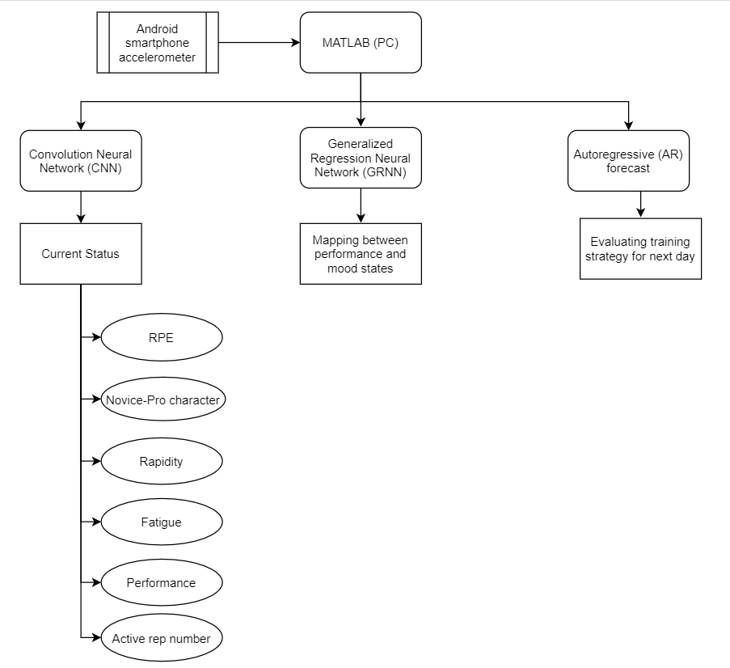

**Figure 1: Overview of project**

# 

Chapter#02

# 3.Background

## 3.1.Machine Learning:

Machine learning is a family of algorithms that is able to construct a mathematical model from ‘training data’ and apply it to fresh data. Machine learning algorithms are used in a wide variety of applications, such as [email filtering](https://en.wikipedia.org/wiki/Email_filtering) and [computer vision](https://en.wikipedia.org/wiki/Computer_vision), where it is difficult or infeasible to develop conventional algorithms to perform the needed tasks.

Machine learning, in essence, is the process of minimizing the difference ‘O’ as,

$$O=Y-X$$

Y= metric on output

X=metric on input

The same concept has been used in classical physics, due to which alternative formulations of Newtonian mechanics was developed as Lagrangian and Hamiltonian mechanics. In process developing rigor on the function ‘O’, machine learning algorithms can be divided into following categories:

* Supervised learning
* Unsupervised learning
* Semi-supervised learning
* Reinforcement learning
* Self-learning
* Feature learning
* Sparse dictionary learning
* Anomaly detection
* Robot learning

These algorithms are implemented on following mathematical frameworks:

* Artificial neural network
* Decision trees
* Support vector machines
* Regression analysis
* Bayesian networks
* Genetic algorithms

### 3.1.1.Image Recognition Example:

#### 3.1.1.1.Binary Logistic Regression

In [statistics](https://en.wikipedia.org/wiki/Statistics), the logistic model is used to model the certainity of a possibilities, a scenario can present. An example being flipping of a coin being classified as either head or tail or even the best strategy in chess being either tactical or positional.

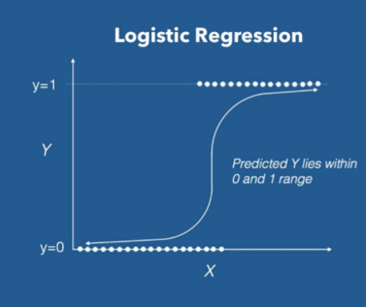

**Figure 2: Decision of elements along X-axis into either y=0 or y=1 forms basis of binary logistic regression**

The hypothesis of logistic regression $h_{θ}\left(x\right)$ is supposed to restrict the cost function between 0 and 1. Therefore linear functions fail to represent it as it can have a value greater than 1 or less than 0 which is not possible as per the hypothesis of logistic regression.

$$0≤h_{θ}\left(x\right)≤1$$

Predicted values are mapped to probabilities using sigmoid function. The function maps any real value into another value between 0 and 1. In machine learning, we use sigmoid to map predictions to probabilities.

$$σ\left(z\right)=\frac{1}{1+e^{-x}}$$

For binary logistic regression, hypothesis function is,

$$h_{θ}\left(X\right)=\frac{1}{1+e^{a_{0}+a_{1}X}}$$

Where, $θ$ is a tuple of two parameters $a_{0}$ and $a_{1}$, and X is input metric.

We expect binary classifier to give us description of a class based on probability when we pass the inputs through a prediction.

For Example, for a two class system, we basically create a reference threshold value, above or below which a specific class would reside.

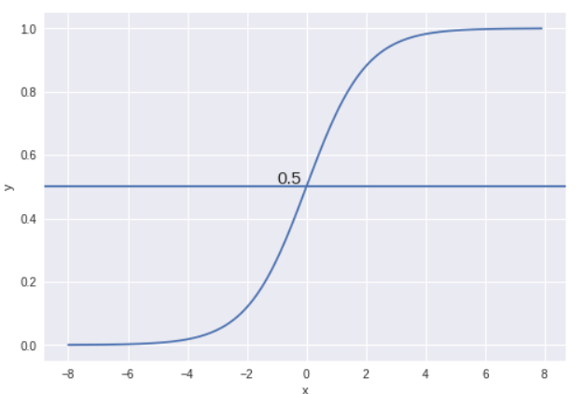

**Figure 3: Graph of decision function**

For a threshold of 0.5, if the prediction function returned a value of higher than 0.5, then we would classify this observation as class#01, otherwise would be classified as class#02.

Now we will use the essence of machine learning, which is to construct the ‘O’ function, which in our case will be a cost function and minimize it to find respective parameters.

$$Cost\left\{h_{θ}\left(u\right),y\right\}=\begin{matrix}-\log\left(h_{θ}\left(u\right)\right) , if y=1 \\ -\log\left(1-h_{θ}\left(u\right)\right) , if y=0\end{matrix}$$

Above function can be expresses as a single function,

$$Cost\left\{h_{θ}\left(u\right),y\right\}=-\frac{1}{m}\sum_{i=1}^{m}{y_{i}\log\left(h_{θ}\left(u_{i}\right)\right)+(1-y_{i})log⁡(1-h_{θ}(u_{i}))}$$

To extract the parameters that minimize cost function, we utilize gradient descent as following template,

$$θ_{j}=θ_{j}-α\frac{∂Cost\left\{h_{θ}\left(u\right),y\right\}}{∂θ_{j}}$$

The extracted parameters can be used to model the hypothesis function for binary classification of new data.

#### 3.1.1.2.Extension of logistic regression towards image:

Image recognition is essentially a classification of the image of an object into one of the possible categories. Best way to deal with machine learning actions of convolution neural networks, due to its architecture dynamics along a 2-D plane.

The binary logistic regression can be transformed into multi-category classification and then extended towards image and this process becomes image recognition, as shown in following figure.

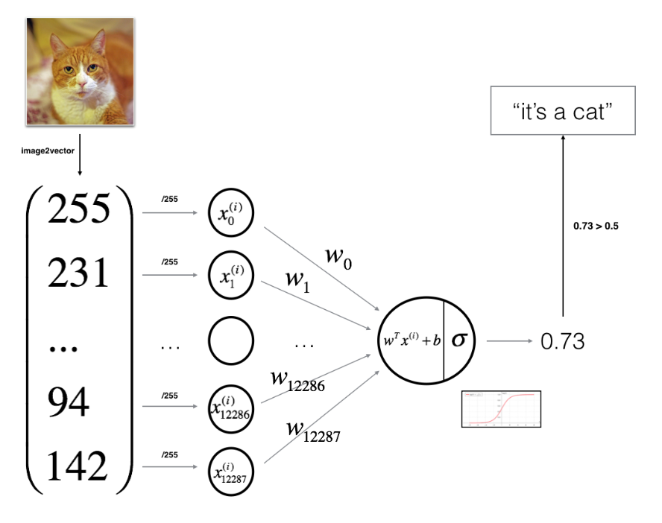

**Figure 4: Overview of convolution neural network classification**

Unique characteristics, called features, are extracted from the image through application of image filters. Once each image is converted to multiple features through feature extraction, with the known labels of the images we can use them to train a model.

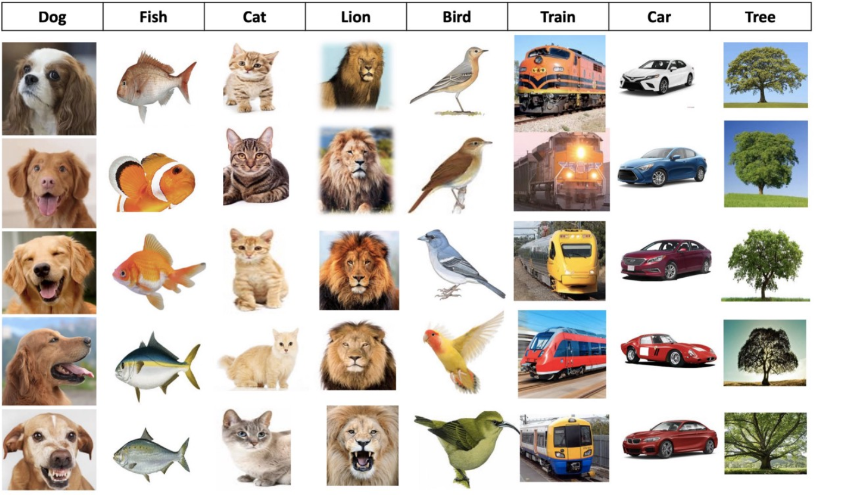

**Figure 5: Dataset for training of neural network**

The more images we can use for each category, the better a model can be trained to tell an image whether is a cat or dog image.

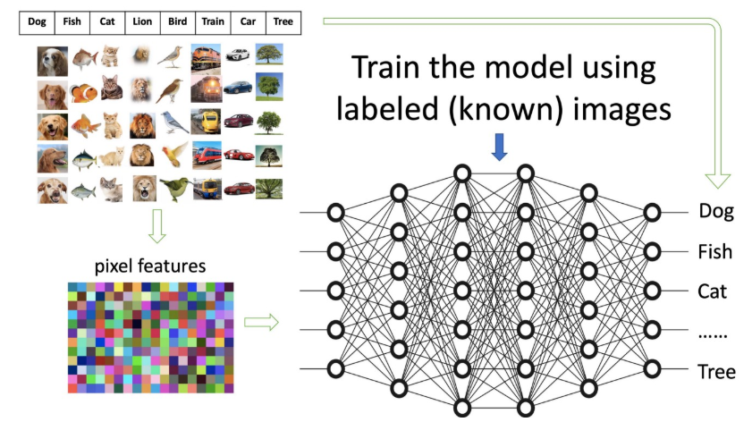

**Figure 6: Training process of neural network**

Once a model is trained, it can be used to recognize (or predict) an unknown image, forexample identify the image of dog as dog.

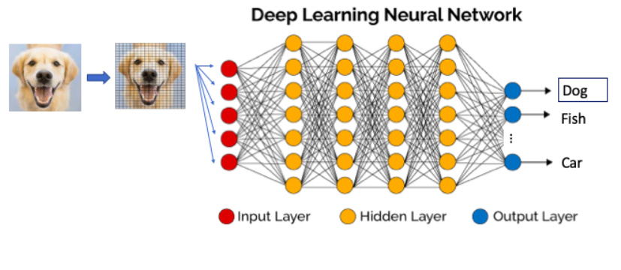

**Figure 7: Testing of trained neural network**

## 3.1.2.Deep learning:

Deep learning is a subbranch of [machine learning](https://en.wikipedia.org/wiki/Machine_learning) methods dealing with mathematical architectures named neural networks with learning algorithms that allows a system to extract an array of features from data alongside with minimization of respective objective functions.

### 3.1.2.1.Convolution Neural Network:

#### 3.1.2.1.1.Neural Network:

**Neural networks are basically graphs whose individual nodes, called neurons, are linear computation units .** Below is the diagram of a simple neural network with five inputs, 5 outputs, and two hidden layers of neurons.

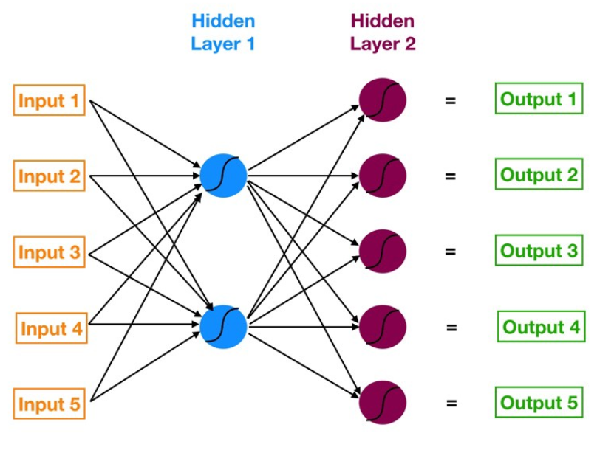

**Figure 8: Overview of Neural Network**

Starting from the left, we have:

* input layer (orange)
* first hidden layer (blue)
* second hidden layer (magenta)
* output layer (green).

These neurons are connected such that output from one neuron becomes input to next neuron and thus introduces complexity of data processing.

Neuron is the fundamental unit of neural network with inputs and outputs. A neuron basically maps input to probabilities.

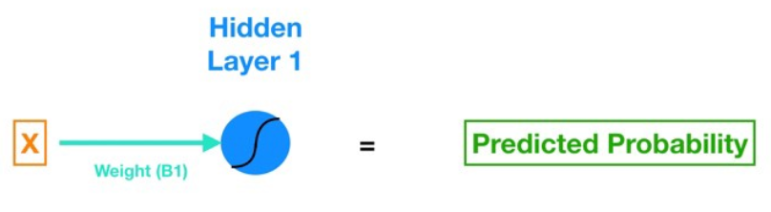

**Figure 9: Action of a single neuron**

Each layer is composed of array of neurons and such layer with inputs coming in and oututs going on forms a matrix linear system as,

$$Y=AX+B$$

Where, Y, X and B are vectors and A is a matrix (basically a juxtaposition of weights). These layers interconnect to add complexity and flexibility in predictions of neural network.

The actions performed on these layers, that make neural networks to learn, can be categorized as ‘forward propagation’ and ‘backward propagation’. Forward propagation is to evaluate output of each neural from their respective juxtaposition, while moving forward. Backward propagation is evaluation of errors and update of weights through individual gradient descent algorithm. These two actions are continued several times, until mean error falls below a certain threshold.

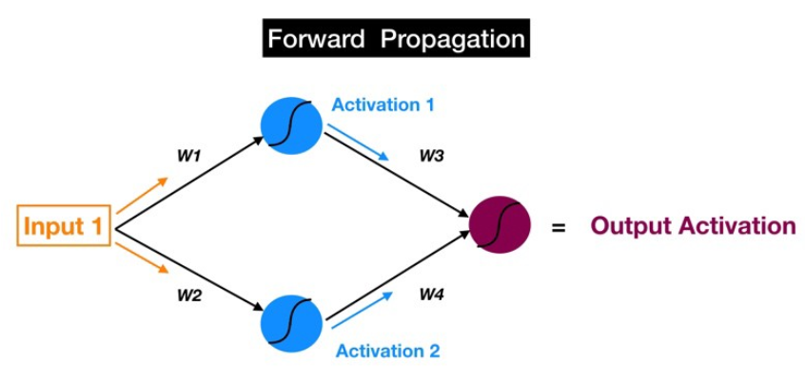

**Figure 10: Forward propagation**

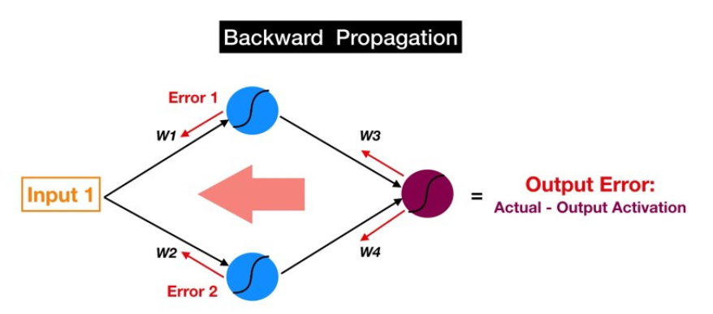

**Figure 11: Backward propagation**

After, the learning process, neural networks are able to predict with desired level of accuracy.

#### 3.1.2.1.2.Convolution version of neural network:

A convolution neural network (CNN) is one of the most popular algorithms of deep learning. As type of deep learning architecture in which a model learns by applying the idea of convolution of two signals towards data types like image, video and sound etc.,have proven to be ideal for application of machine learning on images.

A CNN can have thousands of layers that each learn to detect different features of an image. Filters are applied to each training image at different resolutions, and the output of each convolved image is used as the input to the next layer. The filters can start as very simple features, such as brightness and edges, and increase in complexity to features that uniquely define the object.

A CNN is composed of an input layer, an output layer, and many hidden layers in between, and the number of hidden layers decide the accuracy and flexibility at the cost of computational cost. These layers perform operations that alter their parameter configuration based on what they learned from different features of data. The basic building blocks of convolution neural network are: convolution, activation or ReLU unit, pooling, fully-connected and loss layer.

* **Convolution** puts the input images through set of convolution filters, each of which correspond to certain aspect of an image.
* **Rectified linear unit (ReLU)** the convolution unique features are mapped to probabilities through this layer and transfer them onto next layer as input. They are used to make decision process non-linear and thus more accurate.
* **Pooling** simplifies the output by performing nonlinear down-sampling thus decreasing the computation cost.
* **Fully-connected** performs the basic computation of a input-output systems in the neural network through standard matrix linear transformations.
* **Loss** is the last layer of CNN. Itspecifies how [training](https://en.wikipedia.org/wiki/Training)  deviates the predicted (output) from [true](https://en.wikipedia.org/wiki/Ground_truth) labels through utilization of objective function.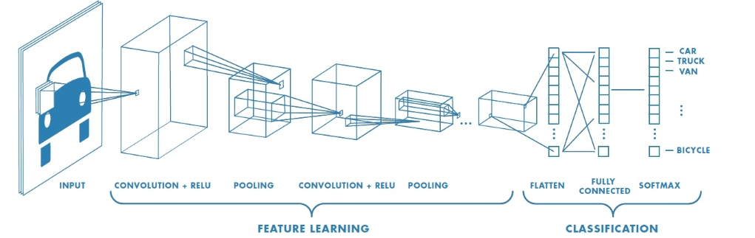

**Figure 12: Resolution of process of convolution neural network classification**

The basic functioning of CNN can be summarized as below:

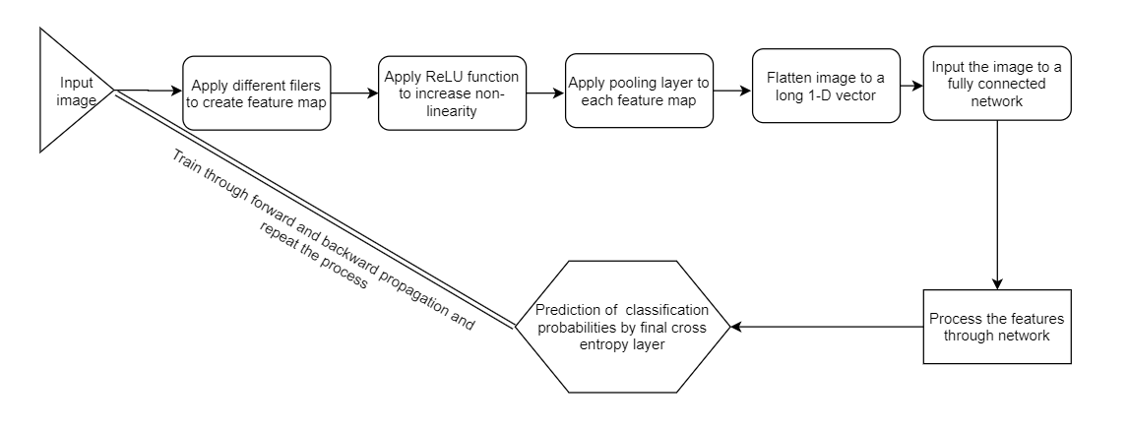

**Figure 13: Flow diagram of process of classification of image by CNN**

### 3.1.2.2.Pre**-trained Model Approach to transfer learning**

Transfer learning is a machine learning technique where a model trained on one task is reconfigured to act on a similar task. It is an optimization that allows improved performance when modeling the second task. Thus, the scope of possible models (model bias) is narrowed in a beneficial way by using a model fit on a different but related task. For the purpose of transfer learning, a pretrained highly accurate neural network will be used and used it well established weights to achieve new objectives, through following steps (https://www.mathworks.com/help/deeplearning/ug/transfer-learning-using-alexnet.html, n.d.):

* **Select Source Model**. A pre-trained source model is selected which has been trained over huge dataset with extreme accuracy.
* **Reuse Model**. The pre-trained model is used on another dataset related to different task, but can induce the benefits of previous model into the next training on possible constricted dataset.
* **Tune Model**. The model’s parameters can be changed on the input-output pairs, as per the problem scenario to get desired accuracy.

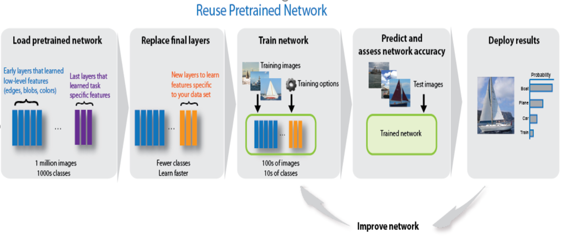

**Figure 14: Transfer learning from pretrained CNN**

Therefore, for purpose of this project, a popular pertained network (AlexNet) was employed in MATLAB. It is 25 layers deep and can classify into 1000 object categories. As a result, the network has learned rich feature representations for a wide range of images. AlexNet competed in the [ImageNet Large Scale Visual Recognition Challenge](https://en.wikipedia.org/wiki/ImageNet_Large_Scale_Visual_Recognition_Challenge) on September 30, 2012. The network achieved a top-5 error of 15.3%, more than 10.8 percentage points lower than that of the runner up. Following illustration is by Alex Krizhevsky, one of the original authors of the AlexNet paper.

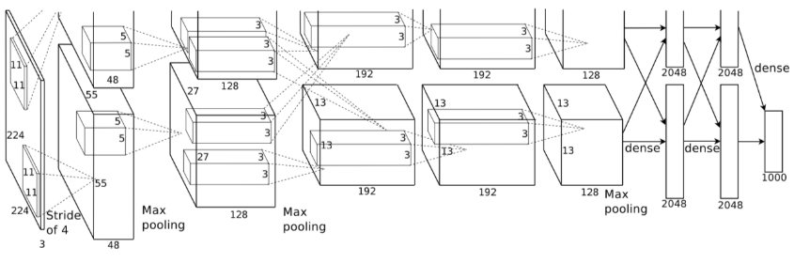

**Figure 15: Illustration of convolution neural network architecture**

Its network structure, in MATLAB ‘Series Network’ file format is available at <https://www.mathworks.com/matlabcentral/fileexchange/59133-deep-learning-toolbox-model-for-alexnet-network>. Its layer architecture is given below.

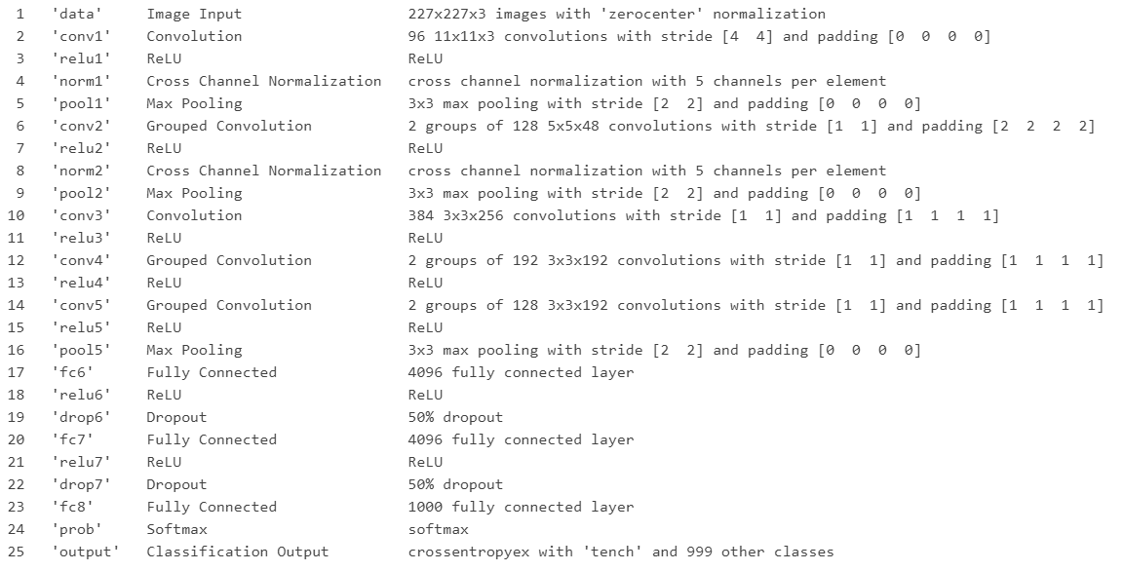

**Figure 16: Layer architecture of AlexNet from left to right numbered from 1 to 25**

## 3.2.‘Myontec’ Muscle Monitor:

Muscle Monitor software is professional software, used by athletes for in-depth analysis of parameters of their training and progress, regardless of sport type. Myontec Muscle Monitor utilizes bio-signals from athletes, like EMG and heartbeat signals etc., to deduce the profile physical attributes alongside with problem detection.

This technology is validated my multiple research studies and training center evaluations and is used by top level sports organizations from around the world. Its features are:

* **“Problem detection”** is collection of algorithms to deduce the performance as well as detect problems in EMG and heartbeat readings. In this way, the level of performance along a signal are highlighted with red, green and yellow color. For example, if Left/Right balance is within +/- 4,5% range the bar graphs are green and if the balance difference is larger the color changes first to yellow (within +/- 7%) and then to red (outside +/- 9%). Similar logic is in use with other parameters too e.g. for relaxation level.

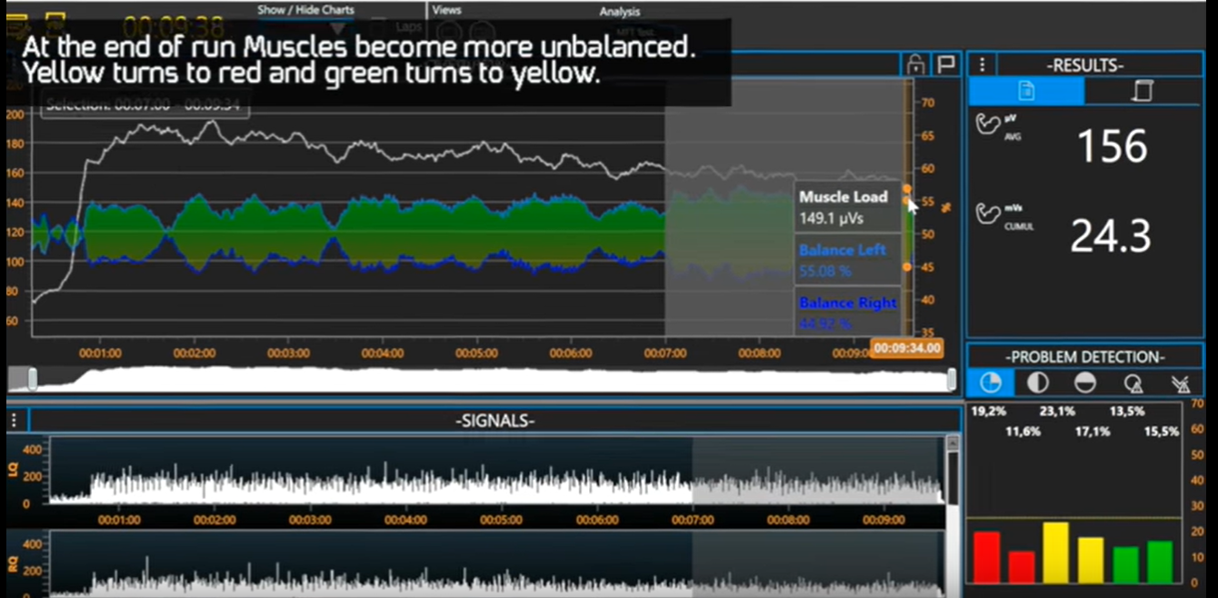

**Figure 17: Problem detection in Mbody interface**

* By detecting **“Muscle fatigue threshold (MFT)”** assigns what part of body should be more focused for training sessions, alongside which muscles are functioning optimally, within levels of basic, speed and maximum endurance, when performing running or cycling.

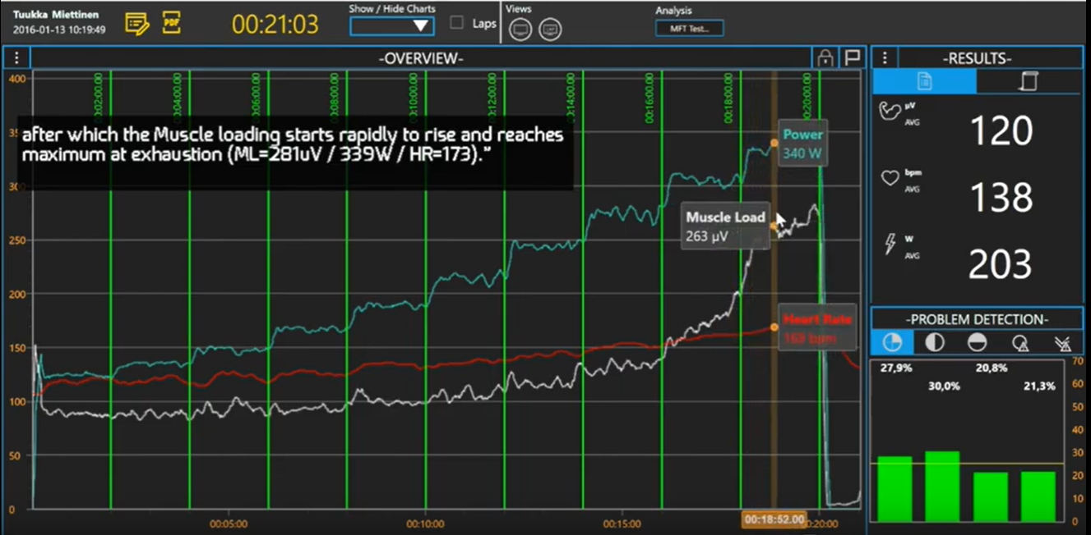

**Figure 18: Muscle fatigue threshold in Mbody interface**

* **“Multi player monitoring”** enables us to monitor performance of multiple trainees simultaneously.
* **“Comparison”** allows markers to be used for comparison of different training parameters like cycling power, averaged muscle load, heart rate, cumulative muscle load.

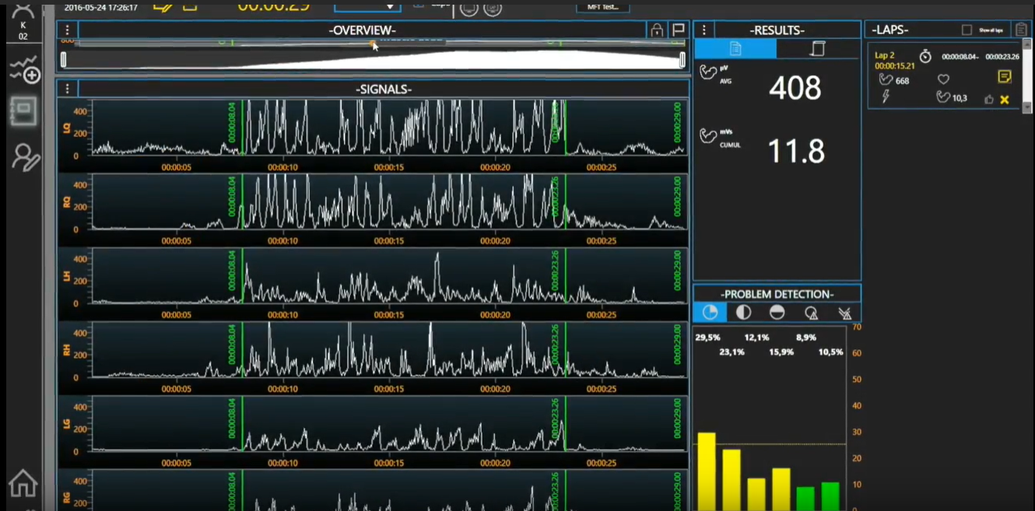

**Figure 19: Comparison in Mbody interface**

* **“Follow-up”** allows comparison of different training exercises to each other to observe the patterns of progress, by drawing charts selecting parameters both on X- and Y-axis’ e.g. averaged muscle load vs. heart rate and thus seeking your efficiency at various phases.

## 

## 3.3.Accelerometer and EMG relation:

The EMG signal is a biomedical signal that measures electrical currents generated in muscles when it contract due to movement of ions in muscle tissues. On the other hand, An accelerometer is a tranducers, which are basically microelectromechanical systems (MEMS), thus detecting changes in voltages caused by proper acceleration of some arbitrary object. Proper acceleration is the [acceleration](https://en.wikipedia.org/wiki/Acceleration) (the [rate of change](https://en.wikipedia.org/wiki/Rate_of_change_(mathematics)) of [velocity](https://en.wikipedia.org/wiki/Velocity)) of a body in its own instantaneous [rest frame](https://en.wikipedia.org/wiki/Rest_frame); this is different from coordinate acceleration, which is acceleration in a fixed [coordinate system](https://en.wikipedia.org/wiki/Coordinate_system).

Simple tasks involving using one limb, like picking up keys or pushups etc., are found to have corresponding accelerometer and EMG readings, as compared to complex tasks involving multiple limbs. As shown in figure below, for simple arm movements, when accelerometer shows waveform, then EMG signal also corresponding waveform. Similarly, no activity of accelerometer signal corresponds to zero activity for EMG signal (Bryce O’Bard, 2018).

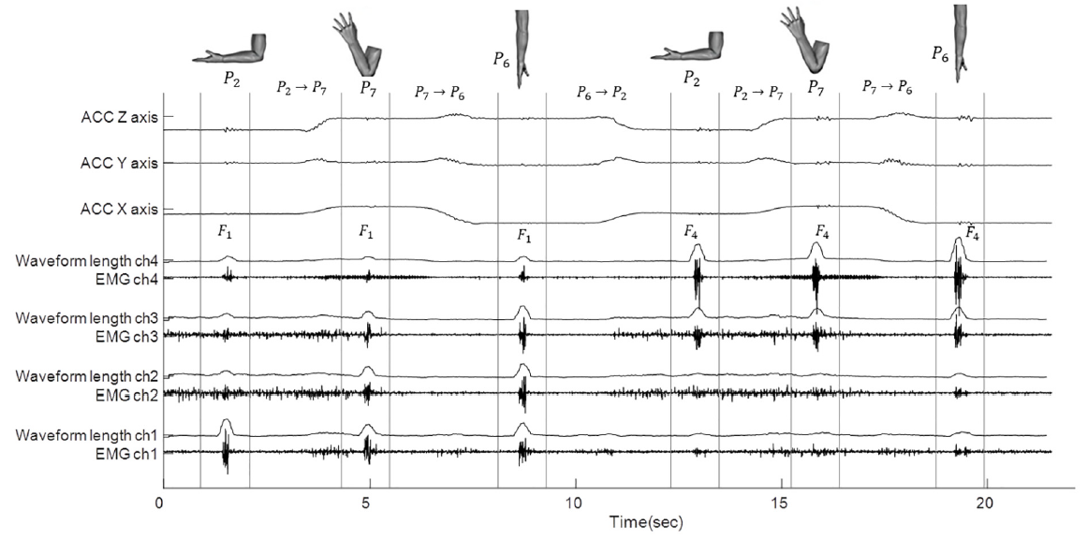

**Figure 20: Changes of raw EMGs and waveform lengths for different arm postures**

## 3.4.Novice Power-Lifting program:

Novice trainees are basically new comer trainees and they have to followed a pre-designed training program to ensure improvement. There are many training programs available, which are chosen according to training requirements and convenience. Some of the programs are given below:

* TSA 9 Week Beginner Program (4 day)
* GZCL Linear Progression Program (aka GZCLP) (3 day or 4 day)
* 5/3/1 N-Suns Linear Progression Program (5 day)
* Candito Linear Program (4 day)
* Ivysaur 4-4-8 Program (3 day)

These beginner programs were chosen for three primary reasons:

1. Focus on the big three competition lifts,
2. Emphasis on weekly linear progression, and
3. Providing adequate frequency for each of the lifts.

A popular simple program is “The Big 3 Routine” given below.

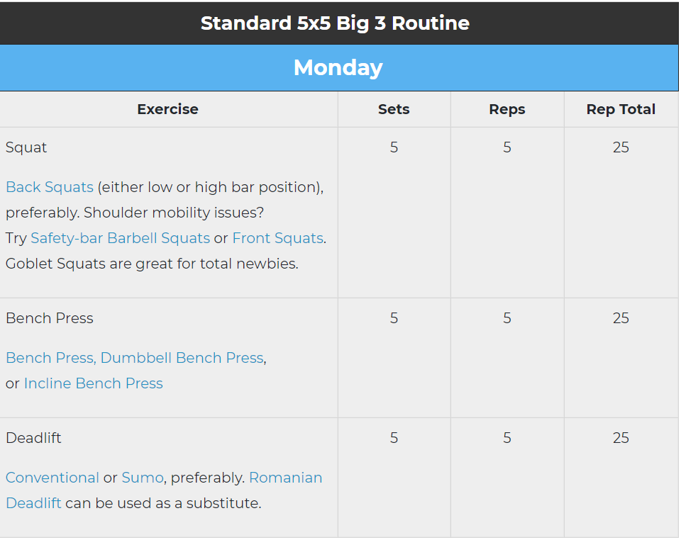

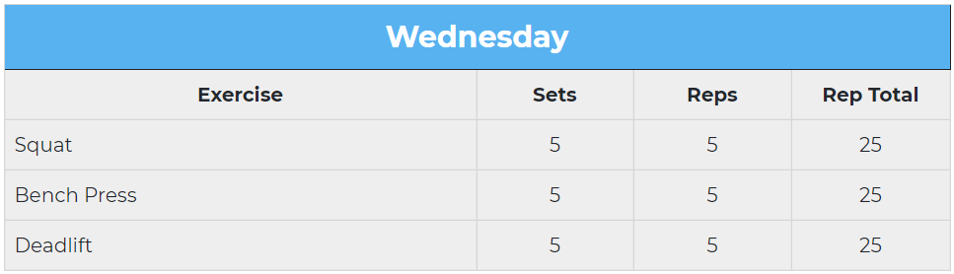

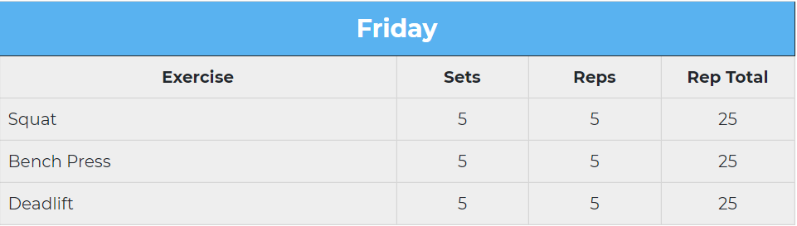

**Figure 21: Basic training program on week basis for power lifting designed for new trainees**

**When to Increase Weight:**

When to increase either load or reps is solely dependent on whether one will breakdown or not. Thus the only way to progress is when increases in load or reps can easily be achieved without fatigue.

**When to Decrease Weight:**

When one is unable to perform 10% of his/her target reps, then for next training session, he/she can reduce the load by 10% for the same volume.

**How Much to Increase Weight:**

Increases are supposed to be steady that allows the body to adapt to the load and not cause any damage. It is different for different exercise, for example: for bicep exercises or squats etc. A 10lb increase in the squat and deadlift, 5lb increase for the bench is common initially for each session. The amount of increase usually forms a curve as:

$$y=m(1-e^{a.x})$$

Where, y=weight lifted

x= number of days

a= training devotion metric

m= characteristic to each trainee

Following represents a sample progression scheme for training in order to ensure effectiveness of training time.

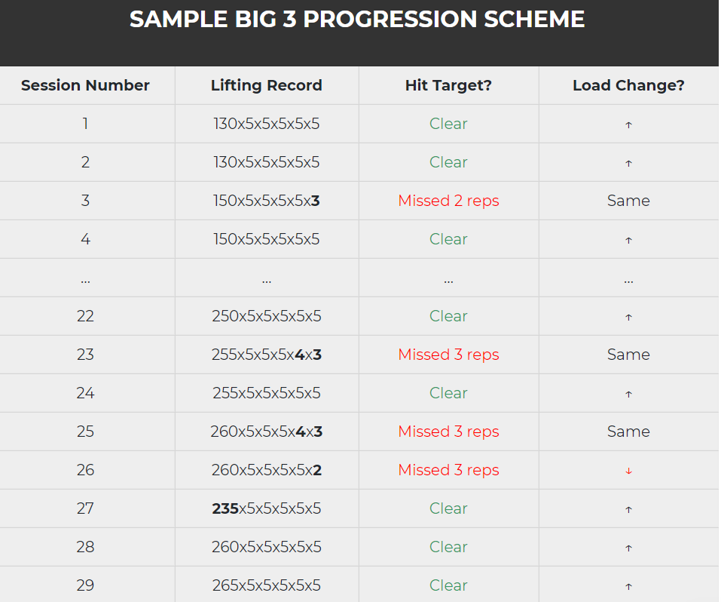

**Table 1: Table showing how to change training routine**

**How Long to Continue Progress:**

Several factors like genetics, present muscle strength and stamina is going to determine how much one can progress. Stamina itself depends on:

* Calories intake balance
* Quality of your diet
* Sleep
* Stress

Flexibility in training is essential for progress in training without damage. Recovery is an essential element of training followed by cutting off some volume or frequency of a particular exercise.

* **Volume:** Volume is basically number of reps followed by number of sets, and it should be adjusted so as to all increase in weight and thus progress.
* **Frequency:**If adjusting frequency doesn’t causes progress, then one may reduce the frequency of exercise and observe if weight can be increased.

Another standard algorithm for progression is:

## 3.5.Relationship of Mood state (POMs) and Exercise:

POMs is a standard psychometric test formulated by McNair et al. (1971), that allows assigning of a number to each mood state, usually through a method of questionnaire. It usually contains 65 statements that describe the feelings people have which are to be answered as either ‘yes’ or ‘no’. The frequencies of ‘yes’ are mapped to mood states like anger, confusion, depression, fatigue and tension. The test requires you to indicate for each word or statement how you have been feeling in the past week including today.

Following is table of mood profiles with associated POMS score (Terry, 2000).

|  |  |
| --- | --- |
| **Mood profile** | **POMS score** |
| Anger | 0-48 |
| Confusion | 0-28 |
| Depression | 0-60 |
| Fatigue | 0-28 |
| Tension | 0-36 |
| Vigour | 0-32 |

**Table 2: POMS score range associated to each mood state**

Terry (n.d.) provides POMS norms for an athletic sample of 2086 participants grouped into international athletes, club level athletes and recreational athletes.

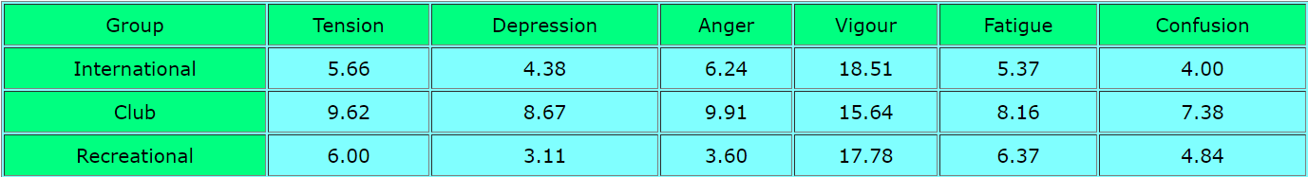

**Table 3: average POMS score of different categories of athlete**

(Morgan, 1978) found that plotting the mood state results of elite performers before competition exhibited the graph below. It has been deduced that with a raised peak for ‘vigour’, was termed the "Iceberg" profile, representative of an elite performer, identified with a Gaussian shaped curve.

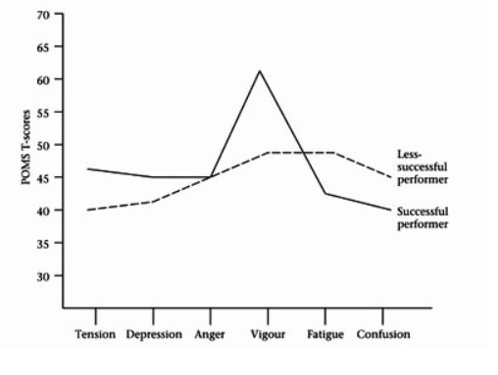

**Figure 22: Graph showing difference of mood state profile for less to more successful performer**

Best athletic performance have different pattern of profile of mood states associated with them, and thus mood profile can act as one of the measure of athletic performance. The more prominent the shape of ‘iceberg’, with greater slop, better the athletic performance (Morgan, 1978).

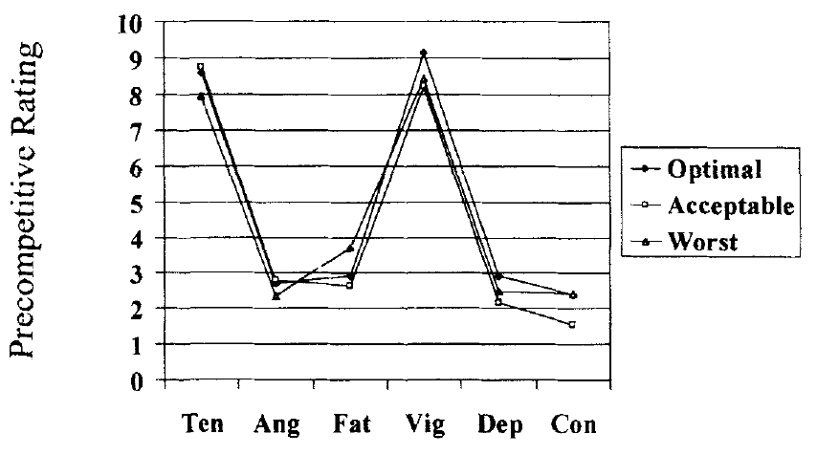

**Figure 23: Graph of showing pattern of optimal performance related to POMS score**

## 3.6.Generalized Regression Neural Network:

It can also be noted that metric used for athletic performance becomes invariant in such case, so that only shape associated with graph of performance vs mood states is preserved. In this way, we can generate performance-state pair, for each mood state, and fit a generalized regression neural network on it (which is inherently fitting a function that would find state value for given performance metric).

A generalized regression neural network (GRNN) is often used for function approximation, thus is used for fitting of functions in sample of input-output pairs, to allow evaluation of unknown output at inputs. It has a radial basis layer and a special linear layer. The architecture for the GRNN is shown below. It is similar to the radial basis network, but has a slightly different second layer.

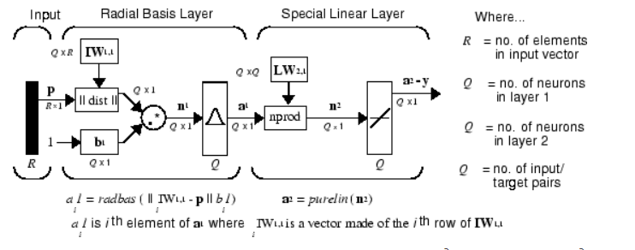

**Figure 24: Architecture of GRNN**

Therefore, for a data pairs distributed in x-y plane, GRNN fits an approximate continuous function and thus can evaluate values at points, were data points are not known.

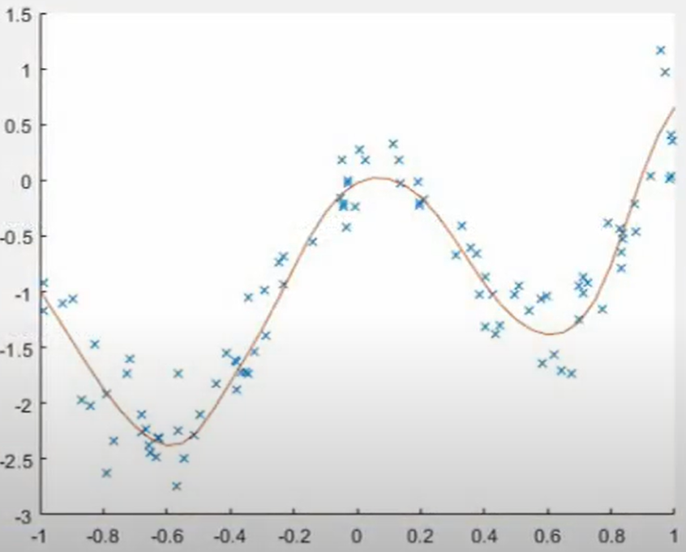

**Figure 25: Graph showing GRNN fitting a function into an array of distributed points**

## 3.7.AR model fitting:

For purpose of forecasting, an AR (autoregressive) model is fitted into time series, to predict future values. The autoregressive model specifies that the output variable acts as function of discrete calculus term accompanied by stochastic term, and thus is suitable for performing regression on real life data, where chaotic elements are present, one example being stock value time series data.

An example is given below, where blue represents a known signal at 100 points, a regression model predicts the red part up to hundred points.

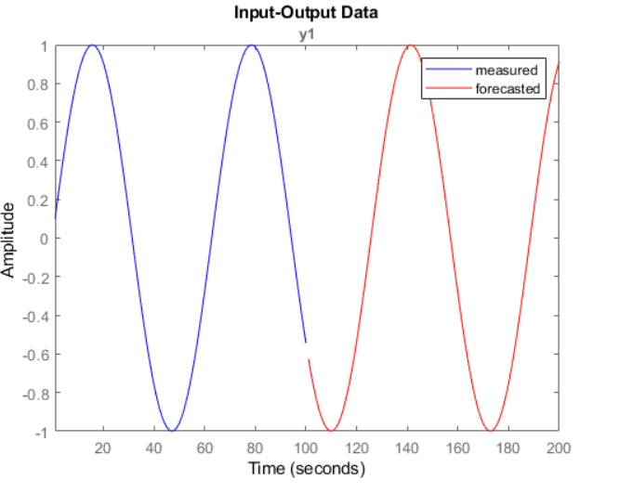

**Figure 26: Graph showing blue curve being forecasted to red curve**

Chapter#03

# 4.Full Specification Decisions

## 4.1.Choosing Muscle Activity Measurement sensor:

An android phone was used to utilize its inbuilt accelerometer sensor and transfer the data to PC. The app used to record accelerometer recordings is **“Physics Toolbox Accelerometer”,** which can record acceleration is (meter per second squared) versus time (seconds) and save in CSV(comma separated values) format.

The phone is placed in a sports arm pouch, which is popular among gym trainees, so adds to the convenience.

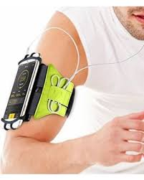

**Figure 27: Sample model of phone pouch**

## 4.2.Choosing Communication module:

There are a lot of methods for transferring files from Android to PC. Here an app named **“AirDroid”** was used. AirDroid is a free and fast Android app that helps you manage your Android phone/tablet from a web browser, all over the air.

## 4.3.Choosing Software and Techniques:

To achieve the concept of fitness training, which is basically monitoring and prediction, MATLAB R2019b was used running on Windows 10, 8GB ram, 2.8 Ghz quadcore processor on Dell latitude 7567.

* For **Monitoring**, the approach was to attach percentages to the accelerometer data of a trainee into character (novice to advanced) and features percentages (fatigue, pace and rapidity). Therefore, AlexNet was used, which is one of pre-trained model in MATLAB neural network repositories. After training on gathered data, the confusion matrix was used to assign probabilities to the features and thus avail percentages.

These percentages were transformed into current performance metrics as RPE, pace and performance as percentages.

In order to identify mood states, data from paper of TERRY, P. (n.d.) “Normative Values for the Profile of Mood States for Use with Athletic Samples” was used where performance was linked to mood states, therefore a regression 10 node neural network was created to attach to performance metrics, the percentages of anger, confusion, depression, tension and vigour.

* For **Prediction**, an AR model is fitted in progress, fatigue and pace percentages of two data readings and predicted to next day behavior, and next day schedule is update accordingly.

The results would be displayed in a GUI, designed in MATLAB’s App designer.

Chapter#04

# 5.Project Management

## 5.1.Time Management:

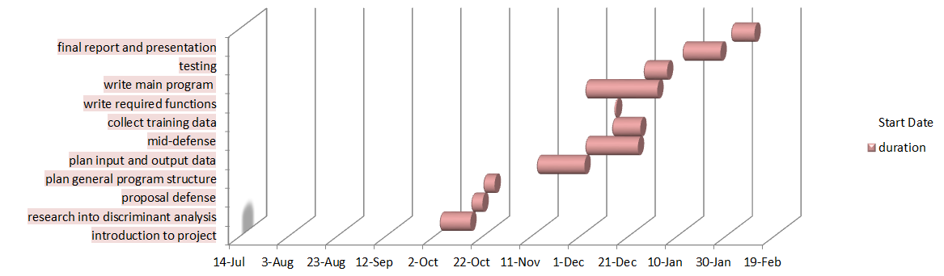

Chapter#05

# 6.Bicep Fitness Trainer

## 6.1.Overview:

Android phone would measure the accelerometer signal during exercise period of gym trainee. The data will be transferred from phone to PC through WiFi, where MATLAB will process the data and present results in performance evaluation and prediction for strategy evaluation, through convolution neural network and neural regression algorithms, and results are displayed in a graphical user interface (GUI).

## 6.2.Introduction:

Fitness training extends to working out all major limbs, therefore in order to apply deep learning on its application as fitness training, some training data regarding activity of all limbs is required. Unfortunately, due to lack of resources online, the major focus of the project is on bicep activity and all strategy of trainer is devised related to it. Training data was collected by convenience sampling, trained on CNN to identify the states of current training, and overall progress and related training strategy was evaluated by AR model fitting.

### 6.3.1. Problem with non-learning algorithm methods for evaluating training parameters:

If we consider that parameters, related to training, are factually function of data (EMG or heartbeat data, etc.) received, then this mapping must be a contraction mapping (meaning that attributes are highly sensitive to variation in data received), because each parameters acts as cause of other and this effect is significant during novice training periods when their bodies aren’t adopted. By famous Banach contraction principle, there exists unique fixed point, and thus there exist unique value of parameters that become independent of the data. This would imply that any algorithm, through finite processing and inferring of data, wouldn’t be able to decide what the parameter is, due to vanishing of function relation at that point.

Therefore, a way to counter this to find a strategy that doesn’t invites this effect, a good example being supervised learning method. Provided with the fundamental fact that such domain of fitness training when implemented engineering wise must be based on the scientific method, and only concept that correlates with it is classification. Therefore, the discussion boils down to using supervised classification for monitoring purpose.

## 6.3.Data Collection and Processing:

For the purpose of this project, in order to access the ability of individuals, there was no such data, regarding performance or progress, was available. Only website “<https://www.openpowerlifting.org/>” provides somewhat similar data but it is regarding elite professionals of how much they pulled weight during professionals, therefore redundant for a general man. Therefore, data had to be collected locally and my choice was convenience sampling. Accelerometer data was collected from 11 male gym trainees from a local gym, “Gemstone Gym”, located in Satellite town, Rawalpindi. Each individual’s consent was acquired, and during their bicep routines, they were courteous enough to allow recording of their corresponding bicep movement data.

### 6.3.1.Pace-rapid-fatigue data:

Since, the ability to carry a specific load is a natural tendency to each individual trainee, therefore collecting data of loads being lifted and their progress seemed redundant, since the data collection span was pretty much one month, and there is hardly any progress in such span.

Therefore, the optimal strategy of correct data collection was to collect data from people with different profiles, that is how long have they been training, alongside with collecting their routine data in categories of:

* **(category: normal):** When doing normal bicep routine with zero exhaustion
* **(category: rapidity):** When doing the same bicep routine, but with faster movements, and thus maximum exertion
* **(category: fatigue):** When doing same bicep routine, when they are maximally exhausted

After one month, total of 42 of accelerometer data samples were collected for this purpose, out of which 14 samples had label “normal pace”, 15 samples had label “rapidity”, and 13 had label “fatigue”.

### 6.3.2.Novice- Pro character data

Another slot of data collection was assigned to how much their bicep actions correlate to characteristics of a professional trainee. Therefore, normal bicep routine of 7 novice trainee were calculated into 20 samples, alongside 10 samples from 4 professional trainees.

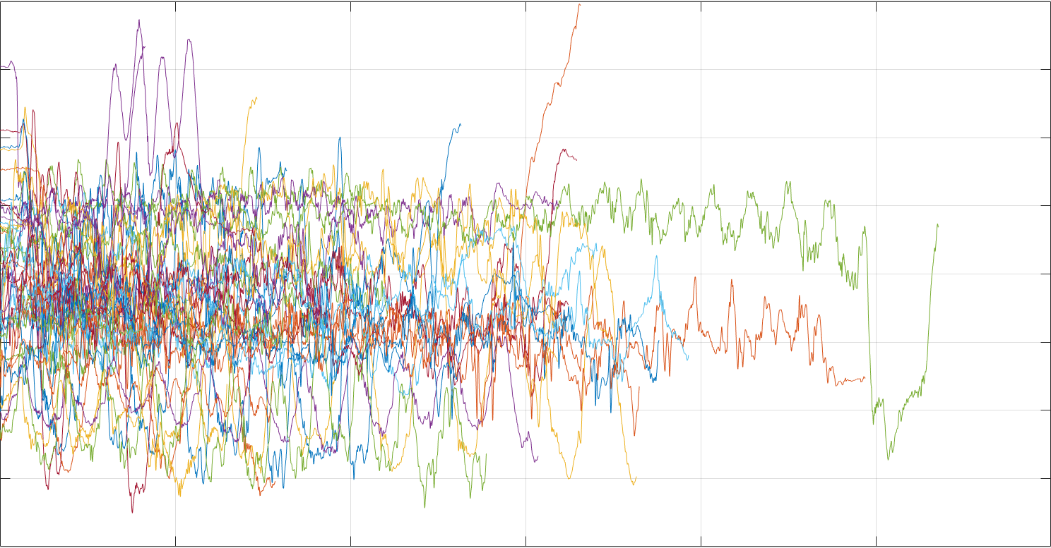

**Figure 28: Combined Accelerometer data (**Pace-rapid-fatigue**) used for performance training in m/s/s**

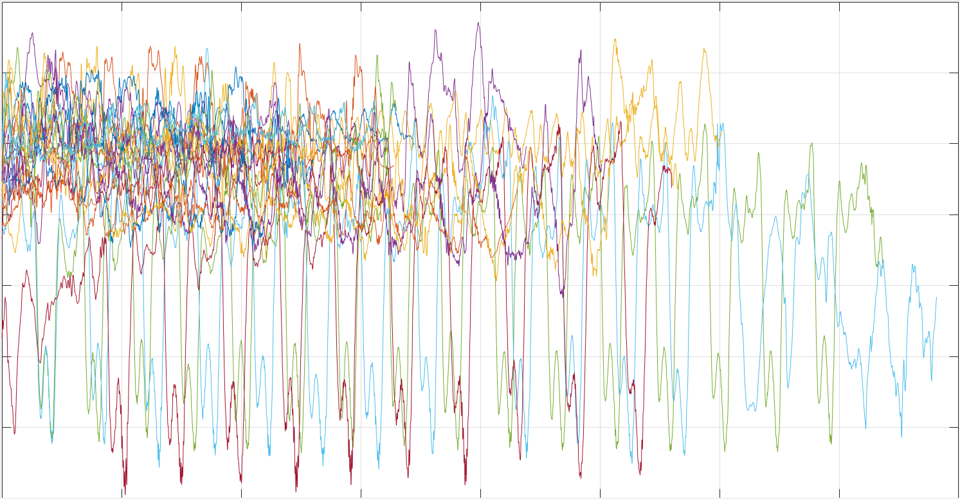

**Figure 29: Combined Accelerometer data (**Novice- Pro**) used for character training in m/s/s**

The ‘pace-rapid-fatigue’ data are individually displayed below, per label:

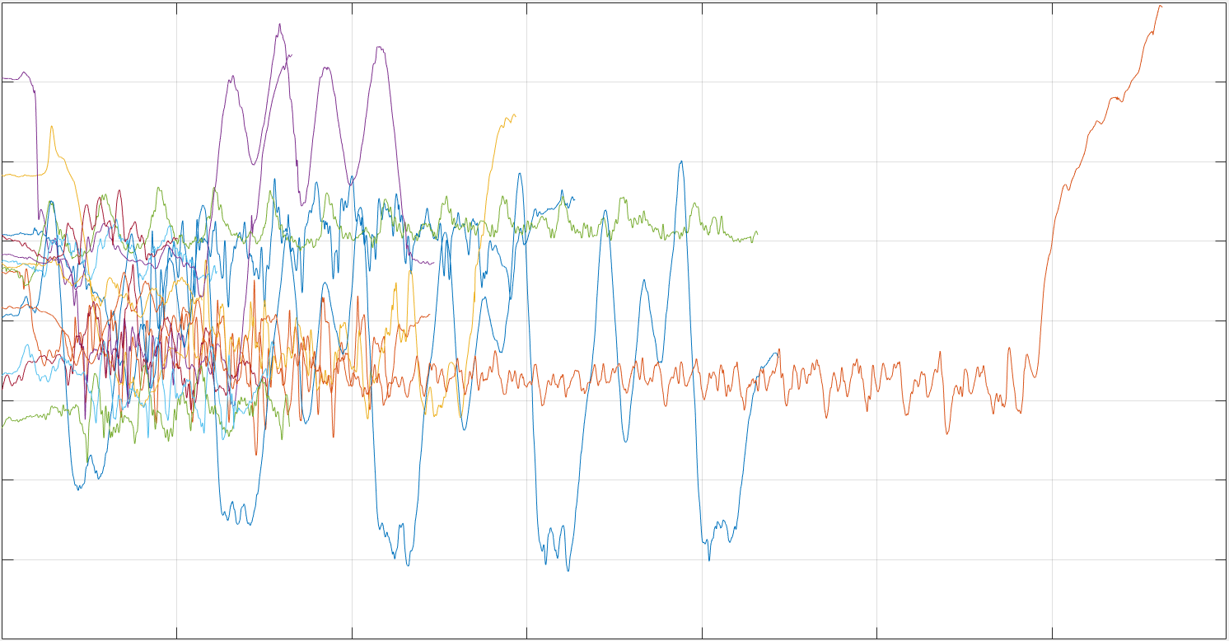

**Figure 29: Accelerometer data when trainees performed bicep reps (pace) with minimal exhaustion in m/s/s**

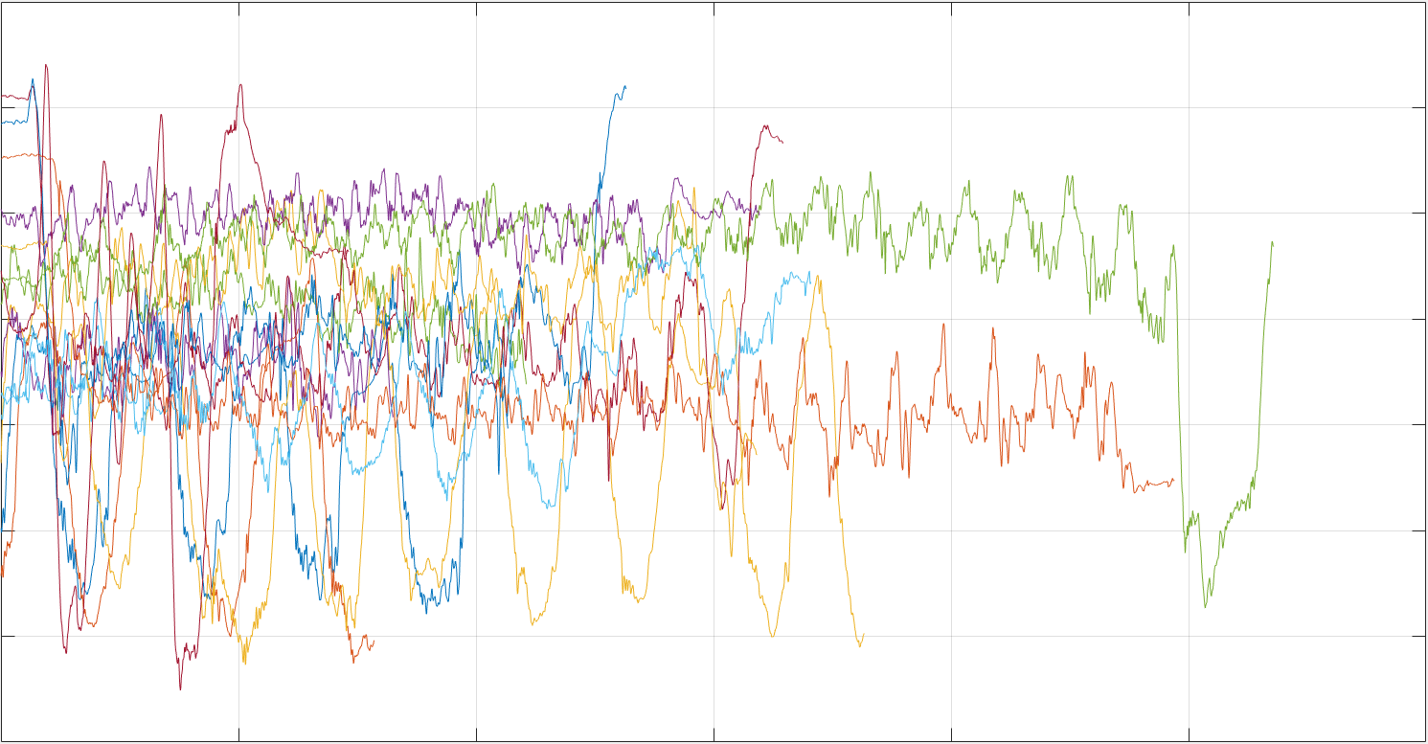

**Figure 30: Accelerometer data when trainees performed fast bicep reps (rapid) with maximal exhaustion in m/s/s**

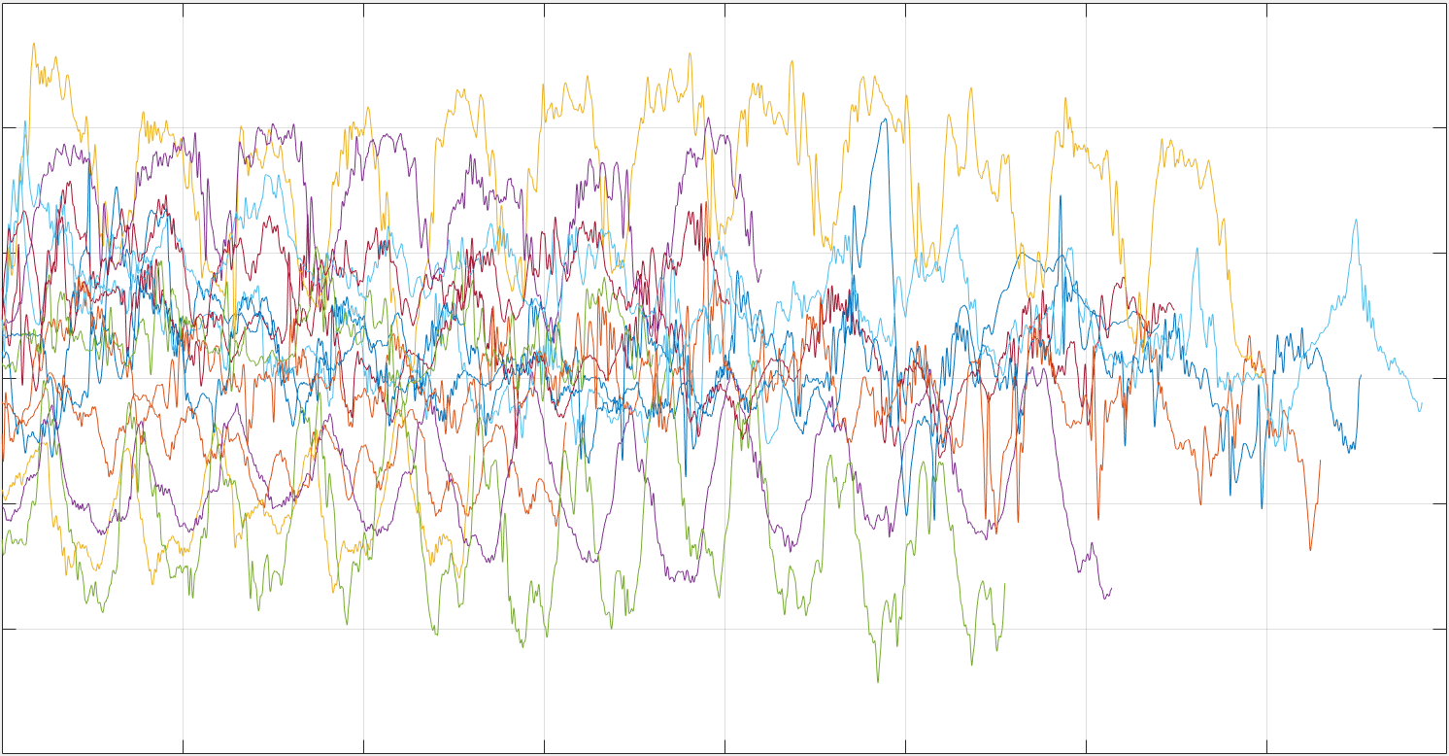

**Figure 31: Accelerometer data when trainees performed bicep reps when feeling fatigue (fatigue) in m/s/s**

Similarly, ‘novice-pro’ data can be displayed below, with individual labels:

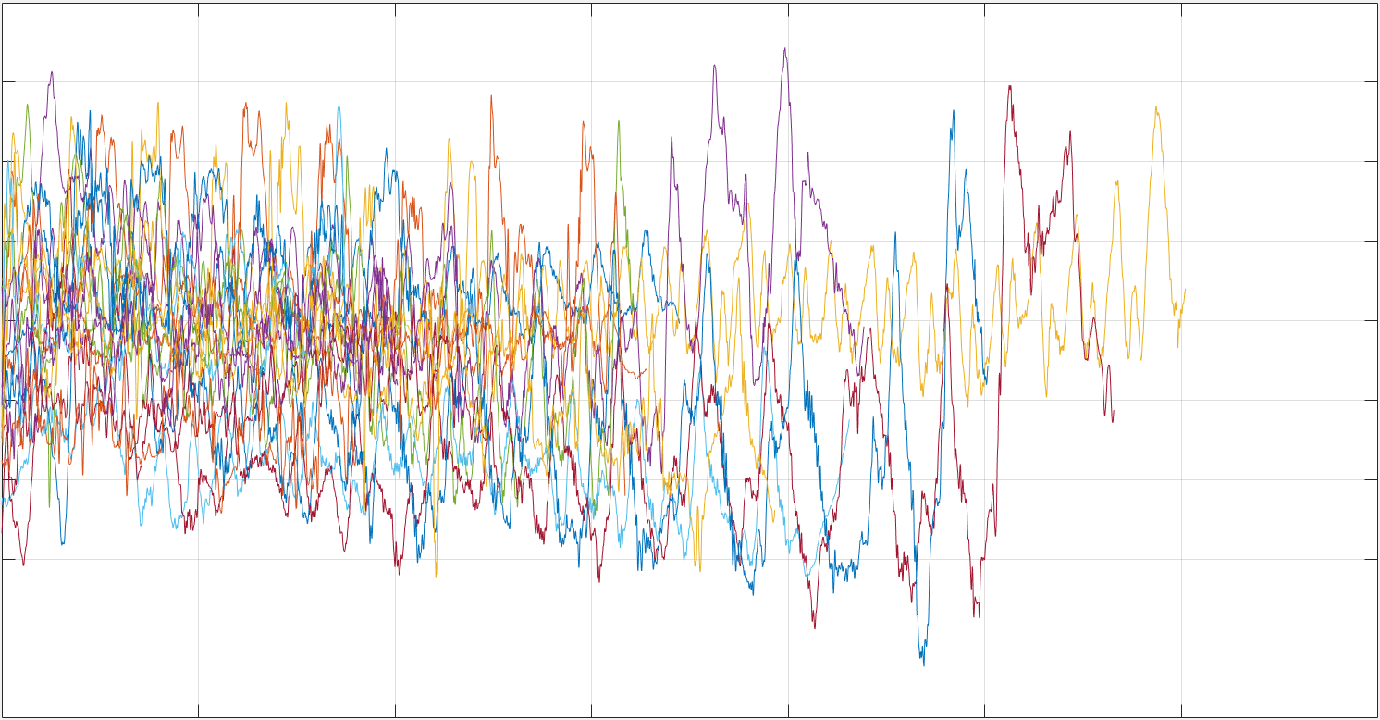

**Figure 32: Accelerometer data of routine bicep of Novice Trainees in m/s/s**

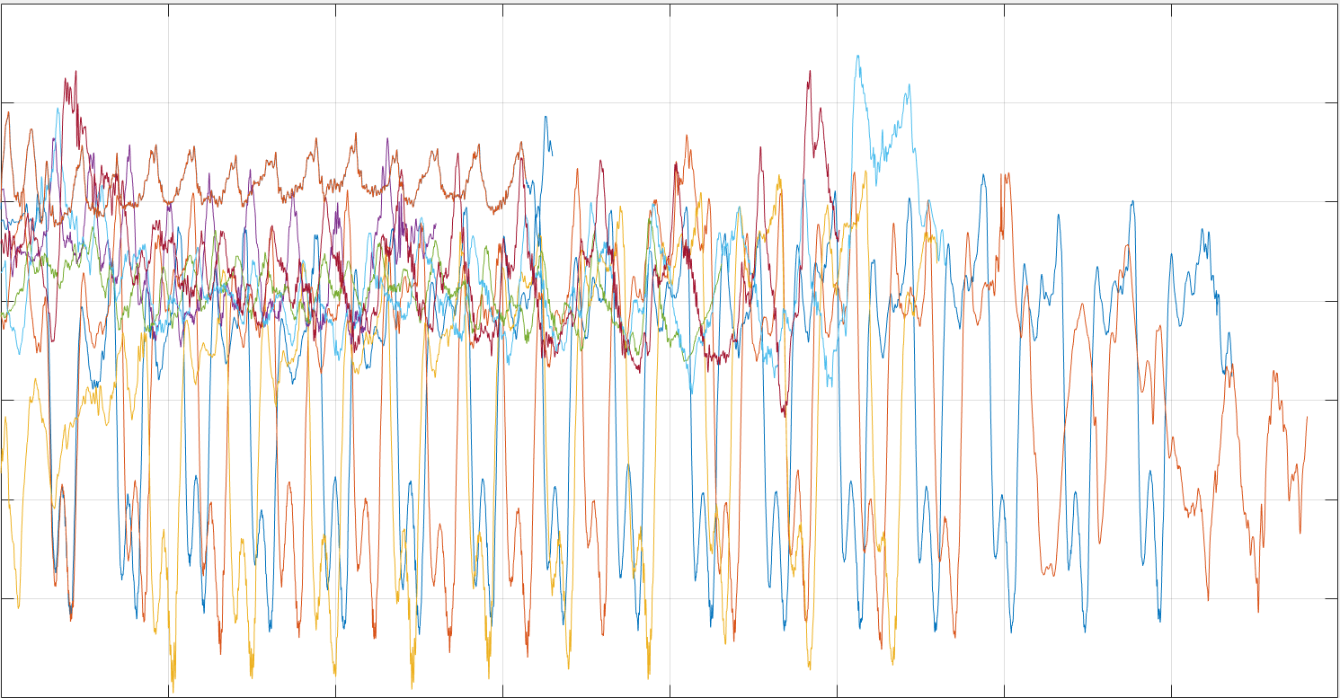

**Figure 33: Accelerometer data of routine bicep of Professional Trainees in m/s/s**

In dealing with evaluating performance of a gym trainee, the data we are getting is an accelerometer signal which is a 1D signal, while CNN inputs either matrices(2D) or tensors. To utilize the CNN for this project, each signal’s scalogram was used.

The scalogram of a signal is the absolute value of the continuous wavelet transform (CWT) of a signal, plotted as a function of time and frequency. The scalogram can be more useful than the spectrogram for analyzing real-world signals with features occurring at different scales — for example, signals with slowly varying events punctuated by abrupt transients. A scalogram is used when one wants better time localization for short-duration, high-frequency events, and better frequency localization for low-frequency, longer-duration events.

Scalogram is computed in following steps:

* **Divide the signal into segments___** Divide the signal into segments of 1 million samples, with 50% overlap between adjoining segments. If the last segment extends beyond the signal endpoint, zero-pad the signal until the last segment has 1 million samples. After computing the scalogram of each segment, remove edge effects. Discard the first 250,000 and the last 250,000 scalogram samples of all segments except the first and the last. Discard the last 250,000 scalogram samples of the first segment. In the last segment, discard the first 250,000 scalogram samples and the samples corresponding to the zero-padded region. Consider, for example, a signal with 2.6 × 106 samples:

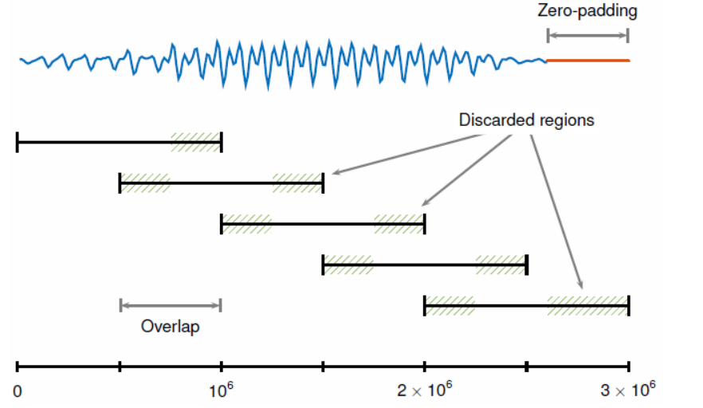

* **Compute Continuous Wavelet Transform (CWT)__** A generalized analytic Morse wavelets with gamma factor γ = 3 is used to compute wavelet transform. The figure shows some Morse wavelets with varying time-bandwidth product P. The real part is in blue, the imaginary part is in red, and the absolute value is in black.

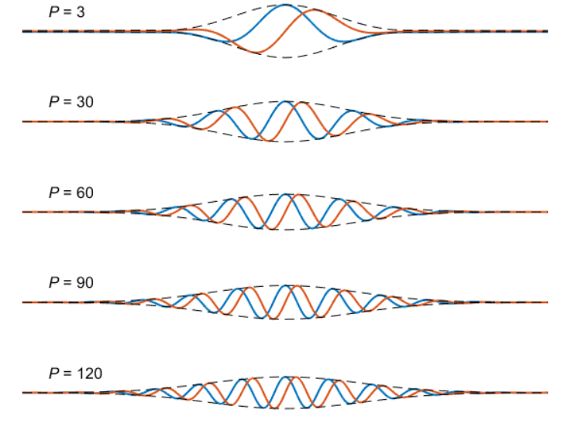

* **Display the scalogram___** Plot the absolute value of CWT coefficients as a function of time and frequency.

Therefore, for a simple sinusoidal of 2Hz frequency, it scalogram would look like below:

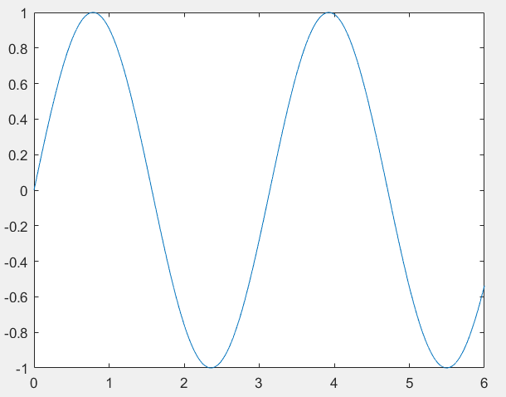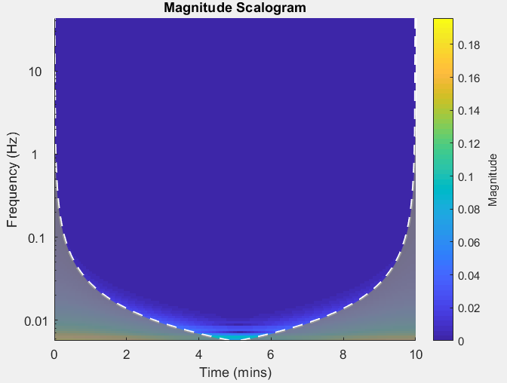

**Figure 34: Single modal Signal plot with its associated scalogram**

Similarly, for signal composed of 2Hz, 4Hz and 6Hz frequency, its scalogram looks like this:

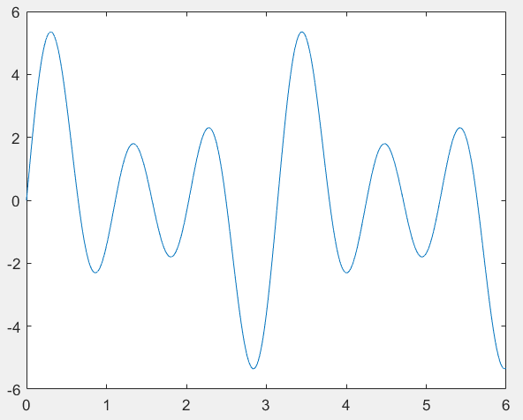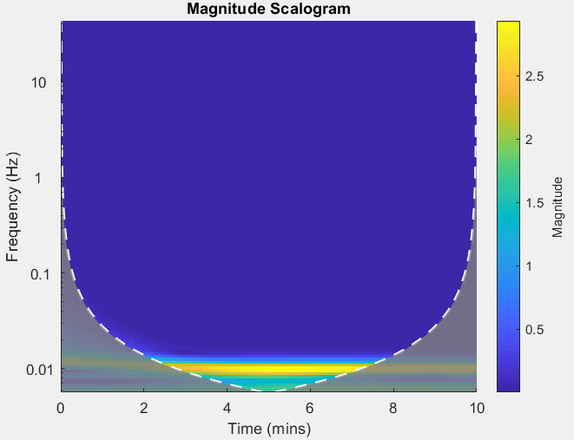

**Figure 35: Multi modal Signal plot with its associated scalogram**

Thus scalogram is excellent choice for transformation from 1-D signal to 2-D signal, while capturing the complete resolution of a signal. These scalograms can easily be converted to images, which are basically tensors (RGB images (NxMx3)) of arbitrary N and M, while AlexNet specifically avails tensors of size 227x227x3. Therefore, these images were readjusted to appropriate size, to become suitable as inputs to AlexNet.

**Figure 36: 1-D to 2-D transformation**

## 6.4.Training Process

For the purpose of training on convolution neural network, each accelerometer signal’s characteristic wavelet scalogram was extracted and saved as (227x227x3) image to create standard training data of neural network (AlexNet).

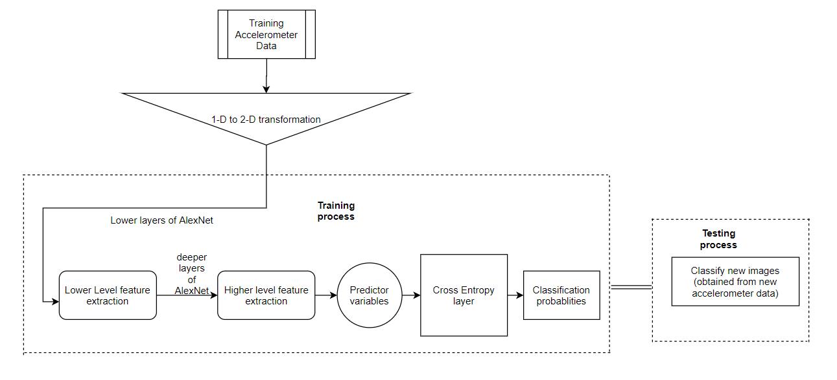

**Figure 37: Overview of training process in frame of project**

It can be noted from following figure that when a bicep movement is either slow or fast, their signals might appear similar, but their wavelet spectrum or scalogram are quite distinct. Notice that, slow bicep signal has magnitudes over low frequencies, while opposite is true for fast bicep movement.

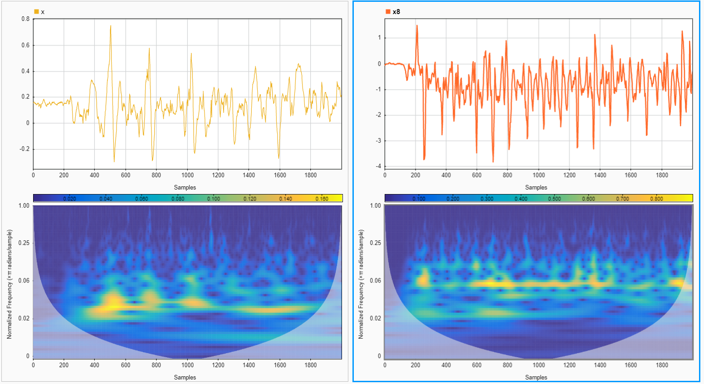

**Figure 38: Left represents slow bicep movement, while represents fast bicep movement with their respective scalograms**

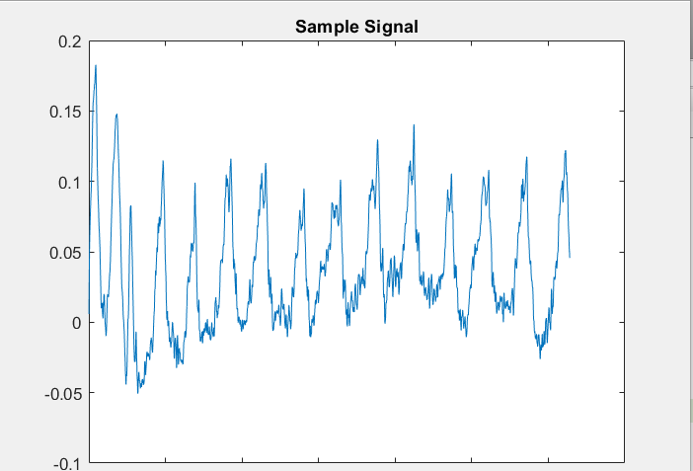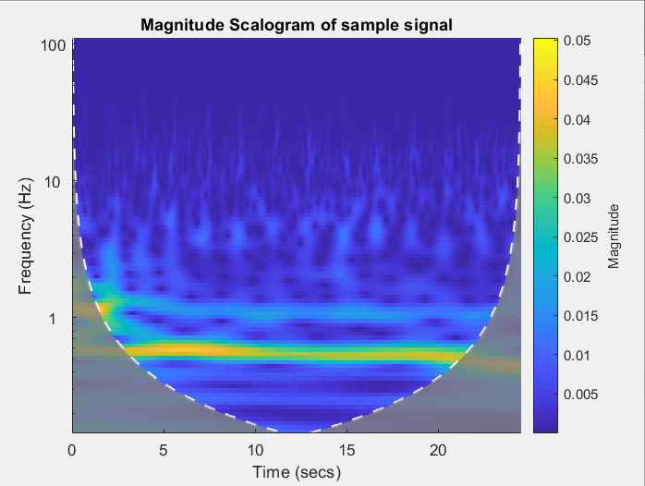

**Figure 39: Sample accelerometer signal plot with its associated scalogram**

The data collected was algorithmically converted into images and stored as dataset.

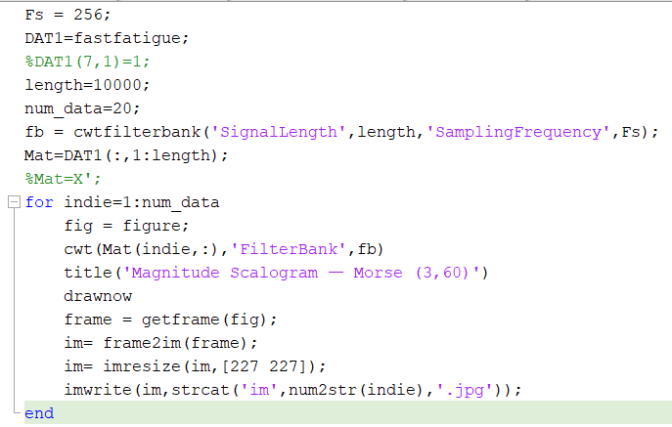

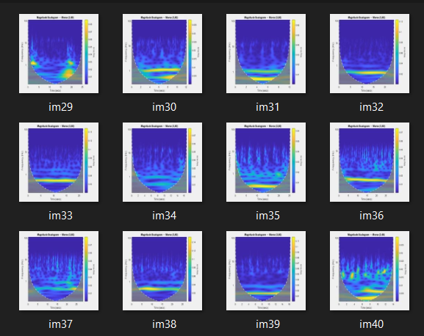

Next, CNN (AlexNet) was then trained on the image data on 250 iterations and the training looked something like this for ‘normal pace’, ’rapidity’ and ‘fatigue’ classification:

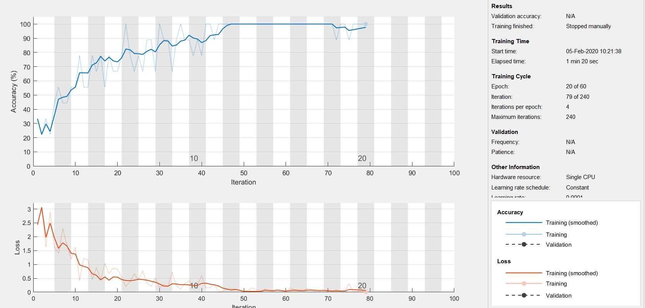

**Figure 40: Screenshot of CNN training on pace-rapidity-fatigue data**

Similarly, another CNN (AlexNet) was used on ‘novice-pro’ data in a similar manner on 250 iterations.

## 6.5.Post-Training

### 6.5.1.Obtaining Confusion Matrix Probabilites

For a following sample accelerometer signal of pulling dumbbell of 6kg at 6 reps, classifying it using “rapidity-fatigue-pace” CNN, creates following confusion probabilities. Alongside, “novice-pro” CNN creates following probabilities.

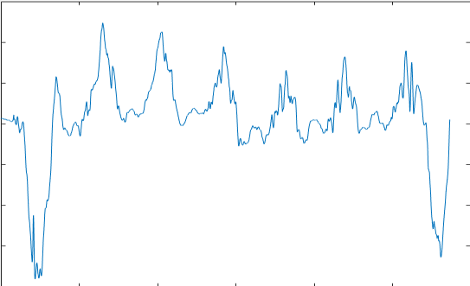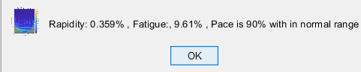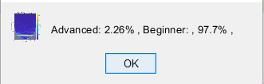

**Figure 41: Plot of a sample trainee accelerometer signal with associated similarity probabilities to different parameters**

### 6.5.2.Creating training strategy:

This section concerns with overall progress and associated prediction to evaluate next day strategy. An AR forecast model is fit into available performance metrics over weeks and predicted on next week basis to evaluate feasible strategy for next week activity. An example strategy used by gym trainers is as follows:

Since the purpose of a personal trainer is to monitor as well as evaluate strategy to either maintain or increase performance. Therefore, for assigning next day load and reps profile, current trend of performance % need to be forecasted, in order to evaluate how to change previous day training parameter. Following graph shows profile of a progression percentage for 4 consecutive training session of novice trainee, forecasted to two next days.

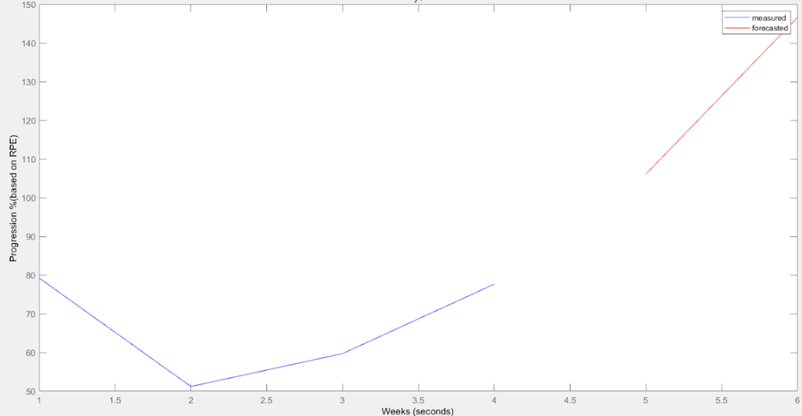

**Figure 42: Plot of 4 day (blue) performance trend forecasted to 2 next days (red)**

### 6.5.3.Number of Reps Calculation:

“Number of Reps” is the identification of number of waveforms accounted in the bicep activity of a gym trainee. It is of essential importance that in each bicep rep, the muscle flexion is maximal which would only then be counted.

In order to count the number of reps, the starting point is to locate local maximas, which is based on fact that derivative of the signal at local maximas is near zero, and second derivative is negative. But, due to roughness of accelerometer data associated with physical exertion, this approach fail, as then the peaks would be counted on each transition of signal.

For a professional gym trainee doing bicep on weight of 4kg, on 14 reps, on just finding local maximas, its corresponding accelerometer data sampled at 254 Hz, when dealt this way produces inaccurate result, as shown in the figure.

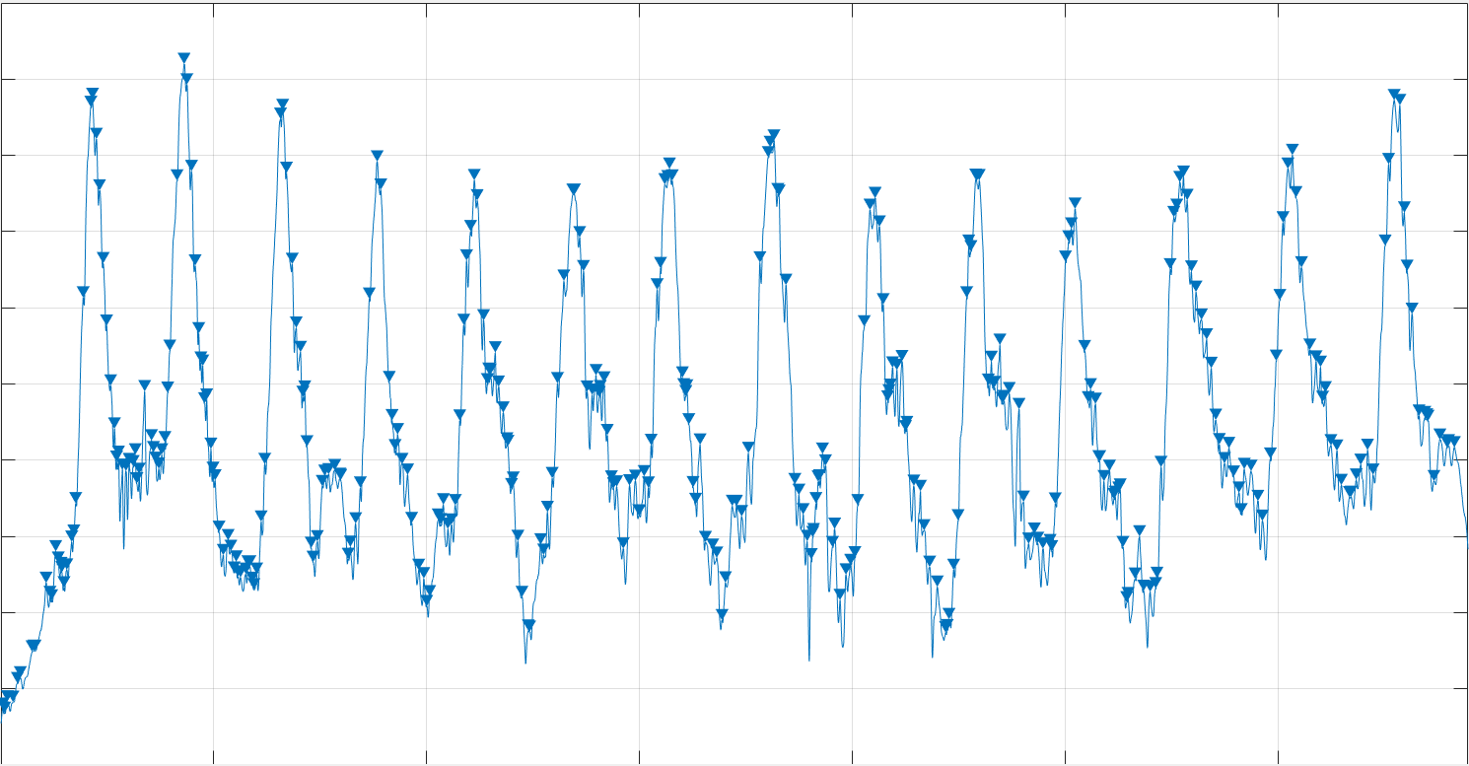

**Figure 43: Plot of the accelerometer signal with detected reps**

The next course of action would be to smoothen the signal, in order to eliminate arbitrary transition. The downside is that human bicep movements are not automated and prone to irregularities. Due to which, waveforms that cannot be associated with a correct bicep flexion would be counted. A good choice is to use Savitzky- Golay filter, which is a digital FIR filter, by fitting subsets of data with low degree polynomials by method of least square. After applying the filter on example data, and then finding local maximas, the result is improved but still inaccurate, as shown in the figure.

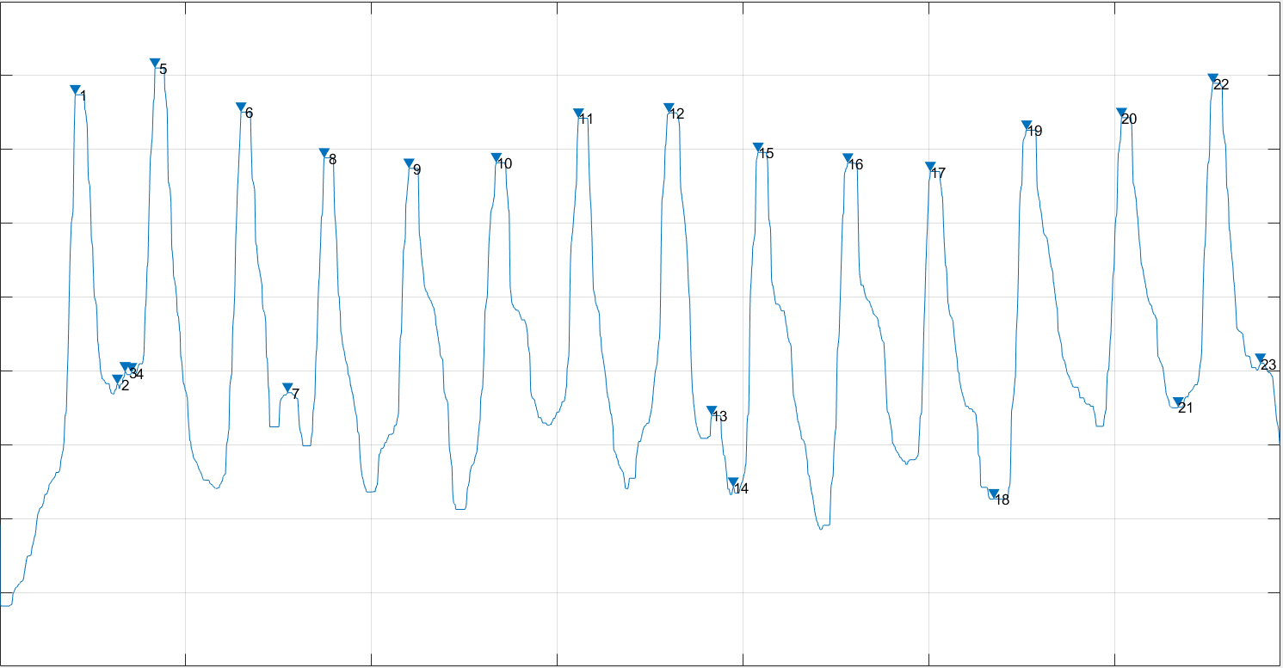

**Figure 44: Plot of a filtered accelerometer signal with detected reps**

In order to deal with this, we need to identify two arbitrary parameters, ‘t’ and ‘N’, in order to characterize what structure waveform, in interval of bicep activity, should counted as rep. ‘t’ would associate to minimum peak height, above which a waveform would be counted as rep as percentage of absolute maximum of data . Simultaneously, ‘N’ would be minimum number of data points, that should exist between two reps. We are able to construct a following general algorithm for counting reps:

1. Apply a smoothing filter (Savitzky- Golay filter) on accelerometer data.
2. Find the absolute maximum of filtered data as ‘M’.
3. Choose suitable ‘t’ between 0 and 1, such that local maxima should be greater in magnitude than t*M.
4. Simultaneously, choose ‘N’ such that two reps distance should be atleast ‘N’ data points apart.
5. Compute first derivative and second derivative of signal such that first derivative is near zero (its absolute value is less than some small number) and its second derivative is negative at those points.
6. Intersection of data points detected from step (3), (4) and (5) are the detected reps.
7. Count the total number of reps

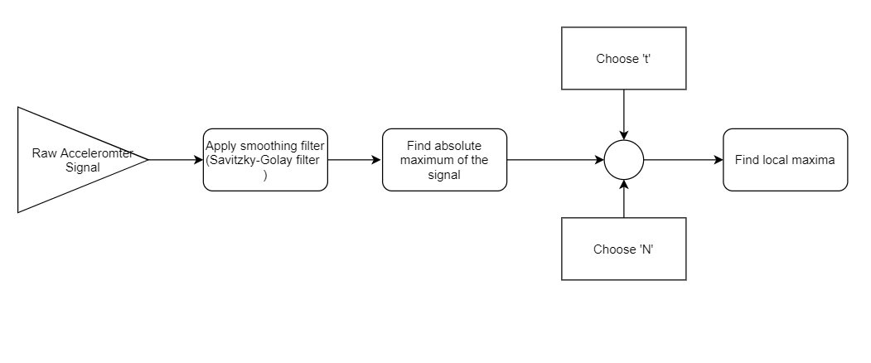

**Figure 45: Overview of reps detection algorithm**

In applying to above mentioned algorithm to our example data, while choosing t= 0.7 and N=200, the detected number of reps are exactly 14 reps, as shown in the figure.

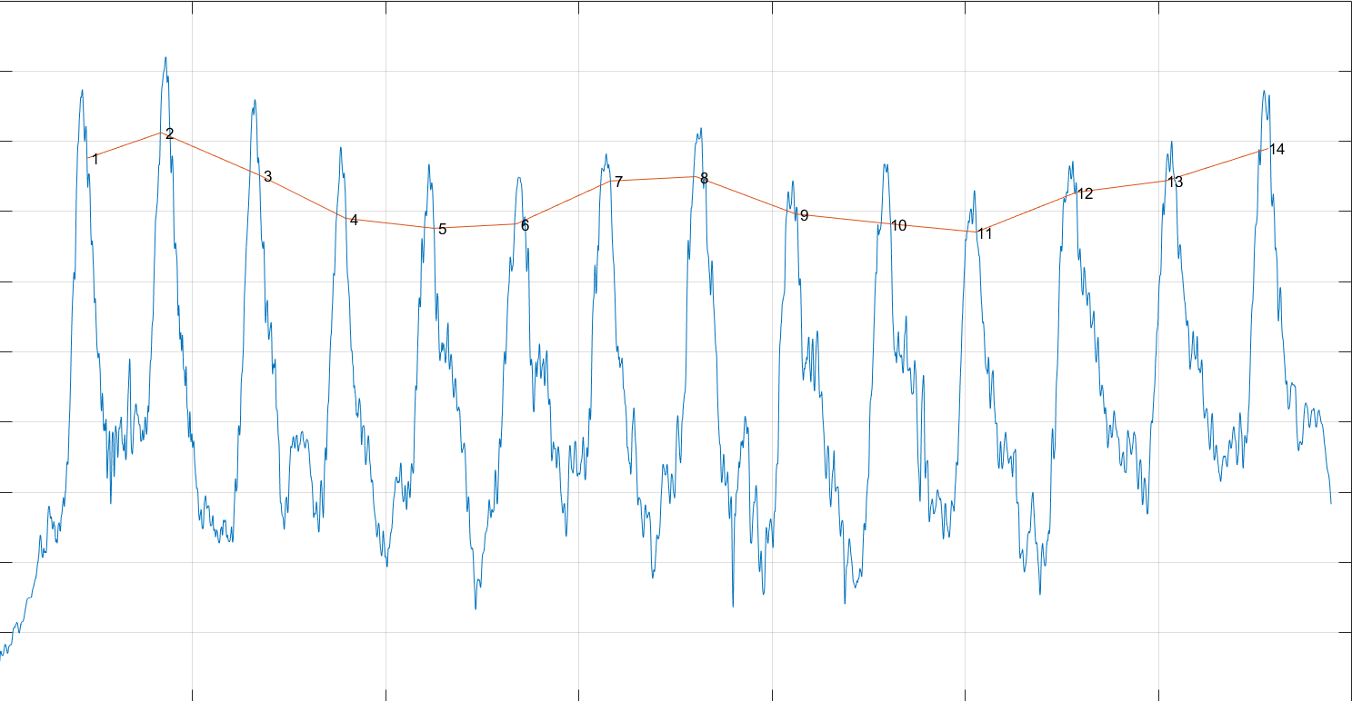

**Figure 46: Plot of the accelerometer signal with detected reps using mentioned algorithm**

### 6.5.4.Current Performance Evaluation

After training of convolution neural network, with average 92% accuracy, the performance evaluation is based on metrics of “Novice-Pro”, “RPE”, “Pace”, “Performance” and “Mood states”, which are based on classification probabilities.

* **“Novice-Pro”** refers to the percentage of how muscle action correlates to a beginner or a professional, obtained from confusion probabilities of CNN classification on ‘novice-pro’ data.
* **“RPE”** refers to rate per exertion which is a performance measure from scale 1 to 10, that how much more reps one can performance after current activity.
* **“Pace”** refers to measure from scale 1 to 10, how much calm, the rhythm of the muscle action is.
* **“Performance”** measure joint metric of RPE and pace.
* **“Mood states”** are actually evaluation of certain moods, that are tension, depression, anger, vigour, confusion by a number scale, through a psychometric test called POMS. There have been studies connecting mood states to athlete’s performances.

Training data used for “RPE”, “Pace”, “Performance” and “Mood states” were “rapidity-fatigue-pace” data. These metrics were calculated from confusion matrix of classification as probabilities ‘r’, ‘f’ and ‘p’ for classification as “rapidity”, “fatigue” and “pace” respectively.

1. **RPE $→$** calculated by mapping probability of “fatigue” (f) to scale 0 to 10 by multiple experiments to identify the range of probability on the RPE scale.
2. **Pace $→$**calculated from probability of “pace” (p) to scale 0 to 10.
$$Pace=p*10$$

3. **Performance $→$** performance is calculated as:
$$performance=\left(1-r\right)*RPE*10$$

4. **Mood states $→$**using the relation tables of POMS test and performance from mentioned resources, mainly from “TERRY, P. (n.d.) Normative Values for the Profile of Mood States for Use with Athletic Samples”, created a regression neural network fitted on POMS metrics as output, performance as input. Therefore, a generalized regression neural network maps performance metric to mood states.

### 6.5.5.Connecting Modules into a graphical user interface

#### 6.5.5.1.Graphical User Interface for Character Classification

For a new accelerometer samples, one of a novice trainee and a professional trainee, were tested on character classification GUI, which utilizes confusion matrix probabilities from character classification ‘CNN’. Novice did the bicep work 3kg load on 9 reps, while the professional did a load of 12kg load on 12 reps. Its behavior can be classified on a scale from 0 to 100, with ‘0’ representative of extreme novice character, and ‘100’ representative of extreme pro-character. It should be noted that movement pattern of bicep is invariant of load, but based on muscle memory.

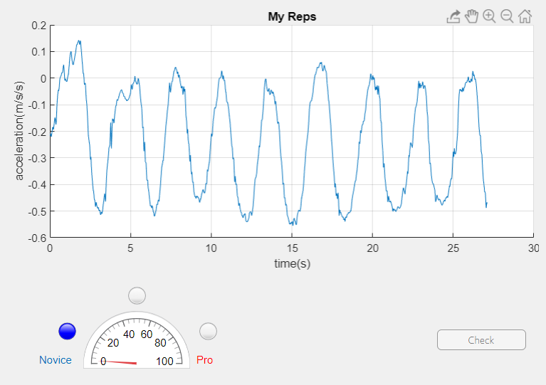

**Figure 47: GUI showing characteristic of a bicep data as of novice nature**

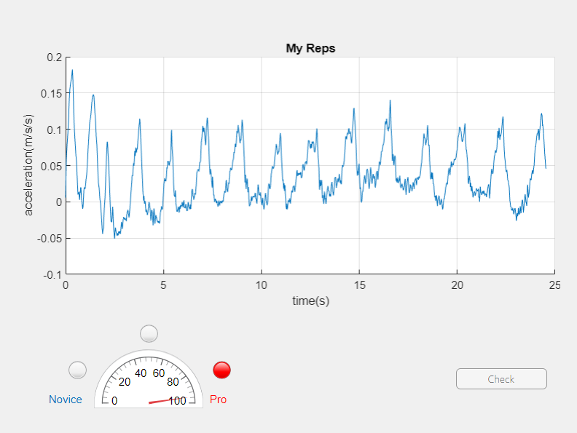

**Figure 48: GUI showing characteristic of a bicep data as of more of what a professional would have**

#### 6.5.5.2Graphical User Interface for Current Performance:

In this GUI, basically following info of a trainee’s accelerometer data is exposed:

* Number of active bicep reps
* Mood states percentages
* Pace percentage
* RPE percentage
* Performance percentage

For a professional gym trainee, performing bicep on 4kg load, on 14 reps, his data is displayed as follows:

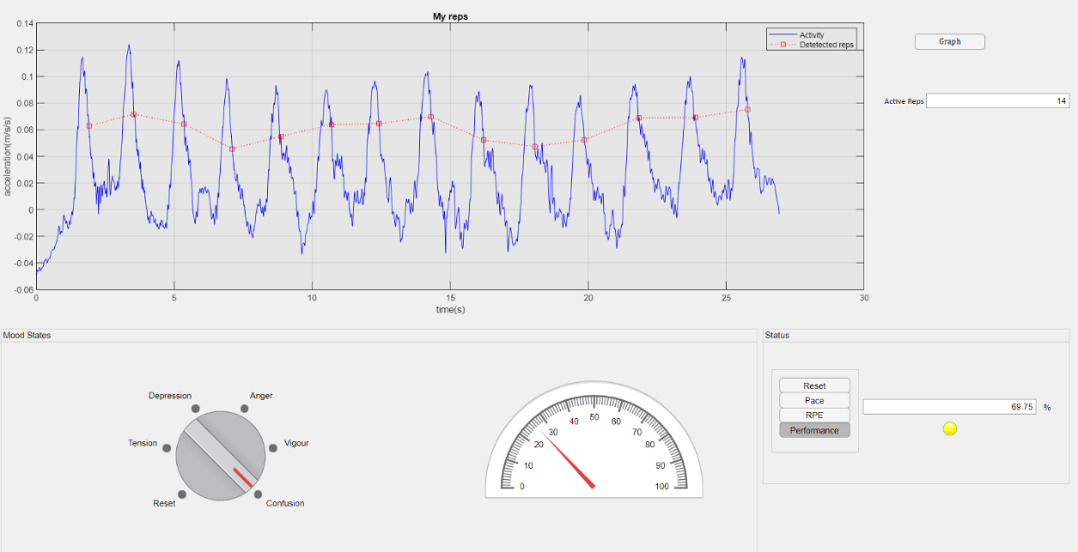

**Figure 48: GUI showing detected active reps, along with percentages of mood states, RPE, pace and performance of a bicep activity**

#### 6.5.5.3Graphical User Interface for Strategy evaluation:

This GUI gives profile of the progress trend in ‘performance’, ‘rapidity’ and ‘fatigue’ category, and based on it, evaluate what load should be taken next training day with associated reps, given what parameters were used current day.

For simulation, a novice trainee’s three consecutive days data was used to create results.

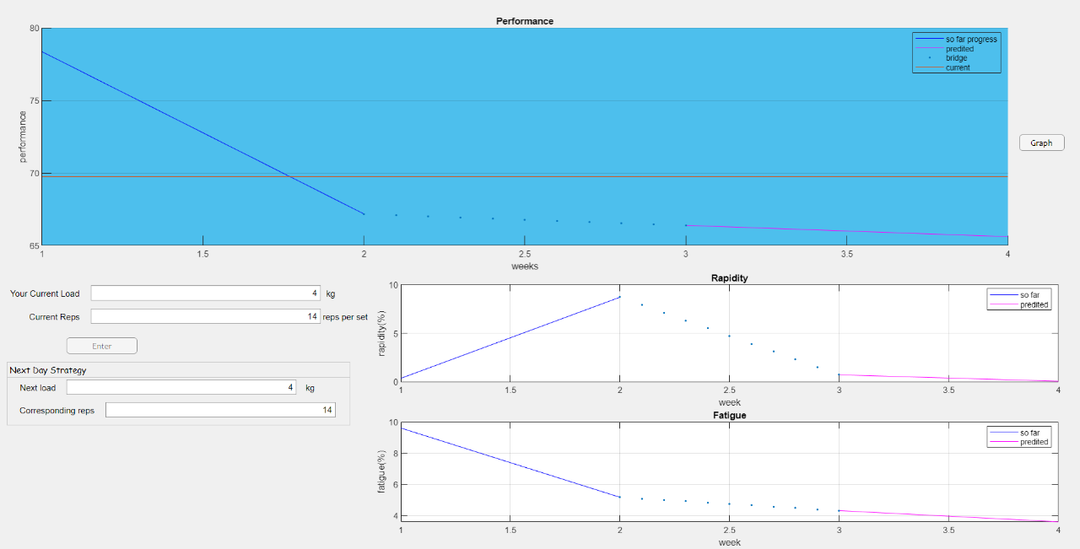

**Figure 49: GUI showing evaluation of next day of parameters given present day along side with profile and forecast of performance, rapidity and fatigue data**

### 

Chapter#06

# 7.Conclusion and Recommendation

## 7.1.Conclusion:

The purpose of this project was to show the integration of deep learning into the aspect of a fitness trainer. Due to lack of any suitable dataset on internet, to achieve the mentioned purpose, the data was self-collected from a local gym with 11 young male trainees through convenience sampling, with focus on bicep workout. The source of data collection was accelerometer. Not only algorithms were implemented to achieve all aspects of fitness training with above 98% accuracy, but also mood states were also deduced from fitness data, which has been researched but never implemented before.

Professional trainers typical charge above Rs50,000 for a simple workout monitoring of a novice trainee. Even if technological alternative are discovered, either they are too expensive or they just provide mere information of physical parameters like blood pressure and so, which essentially is redundant towards the soul of physical training improvement as: monitoring as well as prediction to evaluate a suitable strategy. The mentioned project not only provides it, but also provided deduction of mood states profile.

Although the implementation of project is pretty much software based, an energy and cost efficient approach to implement the project from hardware perspective is also mentioned in ‘Recommendations’ section. Then the resultant project would be equivalent to material that can fit into an arm pouch.

## 

## 7.2.Recommendations:

During a training session, the resultant is basically burning off calories, and these calories go wasted. The number of calories burned in a one-hour weight training ranges from 180 to 266 calories in a one-hour session. If one increase his/her workout intensity to a vigorous training level, his/her calorie burn jumps to between 360 and 532 calories per hour.

Therefore, average power wasted lies between 0.2094 W and 0.6183 W, from above data. Now, when the pouched, strapped to arm, for collecting data is embedded with piezo-electric arrays, with initial assumption that all power delivered by bicep in converted ideally to pressure which becomes in contact maximally to piezoelectric array, then efficiency of such system is known to be 50%. Such array can be embedded in between the layers of fabric of the pouch, where embedded system is place along with rechargeable power source. Thus, when the arm bicep flexes, the pressure is equally distributed along all elements of piezoelectric array.

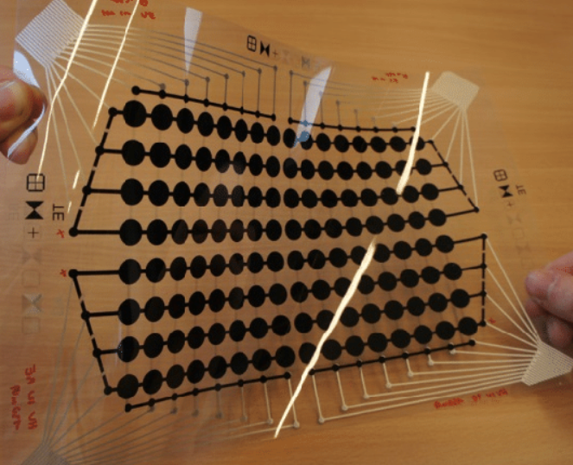

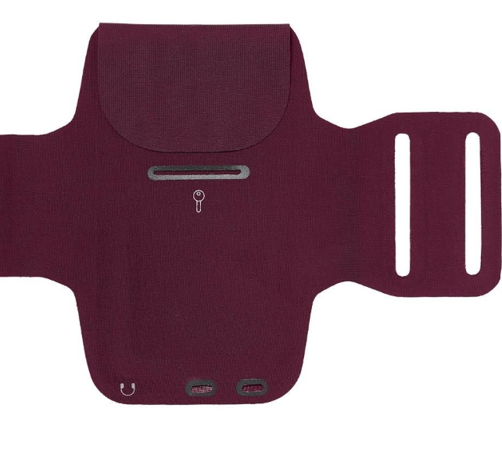

**Figure 50: Piezoelctric sheet to be embedded between layers of the pouch, so that it can absorb the bicep activity pressure**

Therefore, the power generatable through each training session would lie between 0.1047 W to 0.3091 W. These power delivered can be integrated into the main power source, which is a rechargeable battery coupled with a voltage regulator, feeding power to embedded system- accelerometer couple.

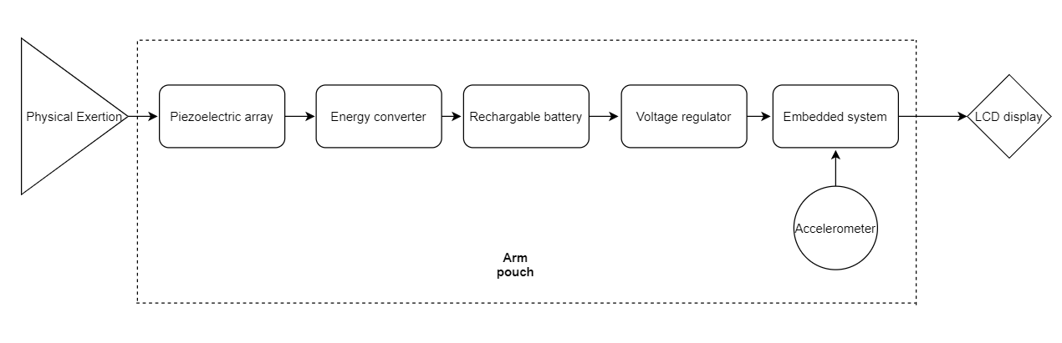

**Figure 51: Overview of hardware implementation of the mentioned project**

For the purpose of embedded system replacement to personal computer, we can replace complex convolution neural network with less computationally intensive state vector machine (SVM) classifier. Still, it is difficult for support vector machines to be employed in microcontrollers because of limited hardware resources. There is some research devoted to implement SVMs in microcontrollers, some keep focus on training SVMs with limited hardware resources, and the other just try to employ SVM models to predict in microcontrollers. The former always do not discuss how to store and learn from a huge number of samples which most applications have to

deal with when using microcontrollers.

A good choice is use ATMEGA SAM3X/A which is a 32bit ARM Cortex-M3 microcontroller, with 84MHz maximum speed, 512 kb flash and 100kb SRAM with peripherals to be able to be integrated with display. The device operates between 1.8-5.5 volts. The time complexity of SVM (pretrained) action is given by,

$$O\left(mk^{0.5}M_{e}\left(k\right)\right)+O(mnM_{d}(n))$$

Where,

m = number of state vectors

n = dimension of input space

k =number of digits of precision of each decision function

$M_{e}\left(k\right)$ = complexity of multiplication algorithm for decision function evaluation

$M_{d}\left(n\right)$ = multiplication complexity in calculating ${\left|\left|x_{i}-x_{j}\right|\right|}^{2}$, where, $x_{i} \&{ x}_{j}$ are state vectors.

Rest of the algorithms, used in project have combined less time complexity than SVM, so the project could be implementable in ATMEGA328P, with sufficient accuracy, given that a pretrained model is implemented in ATMEGA.

The mentioned approach is not only cost efficient, but also energy efficient as well.

# References

(n.d.). Retrieved from https://www.mathworks.com/help/ident/ref/ar.html.

(n.d.). Retrieved from https://medium.com/@maithilijoshi6/a-comparison-between-linear-and-logistic-regression-8aea40867e2d.

(n.d.). Retrieved from https://www.mathworks.com/help/deeplearning/ref/alexnet.html.

(n.d.). Retrieved from https://www.mathworks.com/solutions/deep-learning/convolutional-neural-network.html.

(n.d.). Retrieved from https://www.mathworks.com/help/deeplearning/ug/generalized-regression-neural-networks.html.

(n.d.). Retrieved from https://medium.com/@ksusorokina/image-classification-with-convolutional-neural-networks-496815db12a8.

(n.d.). Retrieved from https://towardsdatascience.com/understanding-neural-networks-what-how-and-why-18ec703ebd31.

(n.d.). Retrieved from https://rippedbody.com/the-big-3-routine/.

(n.d.). Retrieved from https://www.mathworks.com/help/deeplearning/ug/transfer-learning-using-alexnet.html.

(n.d.). Retrieved from https://www.myontec.com/muscle-monitor.

(n.d.). Retrieved from https://www.aworkoutroutine.com/weight-training-progression/.

Bryce O’Bard, K. G. (2018). Classification of Eye Gestures Using Machine. *IEEE Instrumentation and Measurement Society*.

Morgan, W. P. (1978). Personality characteristics of successful and unsuccessful oarsmen. *International Journal of Sport Psychology* .

Prapavessis, H. (2008). The POMS and sports performance: A review. *Journal of Applied Sport Psychology*.

Renger, R. (1993). A review of the profile of mood states (POMS) in the prediction of athletic success. *Journal of Applied Sports Psychology*.

Terry, P. C. (2000). Normative values for the Profile of Mood States for use with athletic samples. *Journal of applied sport psychology*.